Circulated in more than 98 States to the legal and maritime professions

IMLI e-News

The IMO International Maritime Law Institute Official Electronic Newsletter (Vol. 2, Issue No. 12) 22 November 2004

4

“The role of IMLI within the International Maritime Community is certainly useful and necessary : Prof. Guido de Marco

The lawyers attending the 16th LL.M. Course in International Maritime Law, at the IMO International Maritime Law Institute (IMLI) in Malta attended a series of lectures on the United Nations, delivered by the former President of Malta, Prof. Guido de Marco.

Prof. Guido de Marco was President of Malta in the period between 1999 and 2004. Before his appointment he held a seat in the Maltese Parliament for 33 years. He has also held the post of Deputy Prime Minister, Minister for Foreign Affairs and Minister for the Interior and Justice.

In 1990, Prof. de Marco was elected President of the United Nations General Assembly (45th Session). During this time he initiated a dialogue, that later led to presidential motion unanimously approved, to revitalize the General Assembly and other aspects of reform necessary during a time of transition in international relationships.

Since 1967 he has been a lecturer and later a Professor of Criminal Law at the University of Malta.

Prof. Guido de Marco

Prof. de Marco, how do you see the role of the United Nations in nowadays world ?

I think that the role of the UN in our days is even more relevant than ever. Most governments have reached the conclusion that the world needs more United Nations, not less United Nations.

What is the role of IMLI within the international maritime community ?

I think that the role of IMLI within the International Maritime Community is certainly useful and necessary. It is of the utmost importance that the Law of the Sea be studied in depth, the more so, when one considers, the many oil tankers plying the oceans, which can cause environmental damages of great consequences.

The fact that IMLI is based in Malta and that Malta has registered in its name, one of the largest mercantile fleets, reflects the relevance that maritime institutions have in Malta and through Malta. It is worth noting that Malta’s Commissioner has been appointed in the European Commission, to look after fishing and maritime matters.

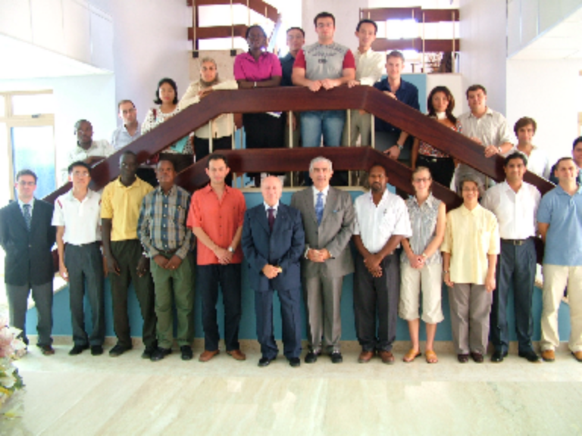
Prof. Guido de Marco, with the IMLI Class 2004/2005 and members of the IMLI staff.

What are your general impressions about IMLI ?

I think that IMLI has the advantage that that its students have already reached a level of maturity in their own countries. This makes lecturers better prepared to express themselves and give their personal thinking on issues, which requires both attention and further study.

IMLI is performing a useful task through its alumni worldwide, who see in our Institute their Alma Mater. It is a matter of pride for them, that they owe their degree to their studies in Malta. I am confident that the many graduates that today, spread out in the world, carrying out important tasks in maritime affairs, create a network of contacts, which will certainly prove useful in the maritime field in the years to come.
_______________

* For further information please contact Mr. Mitja Grbec (Editor, IMLI e-News) at publications@imli.org

**Should you wish to be removed from our mailing list, please send an email to publications@imli.org

