Circulated in more than 100 States to personalities in the legal and maritime professions

IMLI e-News

The IMO International Maritime Law Institute Official Electronic Newsletter (Vol. 2, Issue No. 25) 28 March 2005

IMLI PAYS TRIBUTE TO A MAN OF VISION

On the 24th March 2005 the news of the demise of Dr Joseph M. Fenech reached the IMO International Maritime Law Institute. In a message marking this sad event the Governing Board, Director, staff, students and graduates of the Institute paid tribute to Dr Fenech, a founding father of the Institute, and recalled his foresight, initiative and determination in establishing and promoting the Institute thereby inculcating in generations of lawyers from 103 States the vocation to serve the rule of international maritime law.

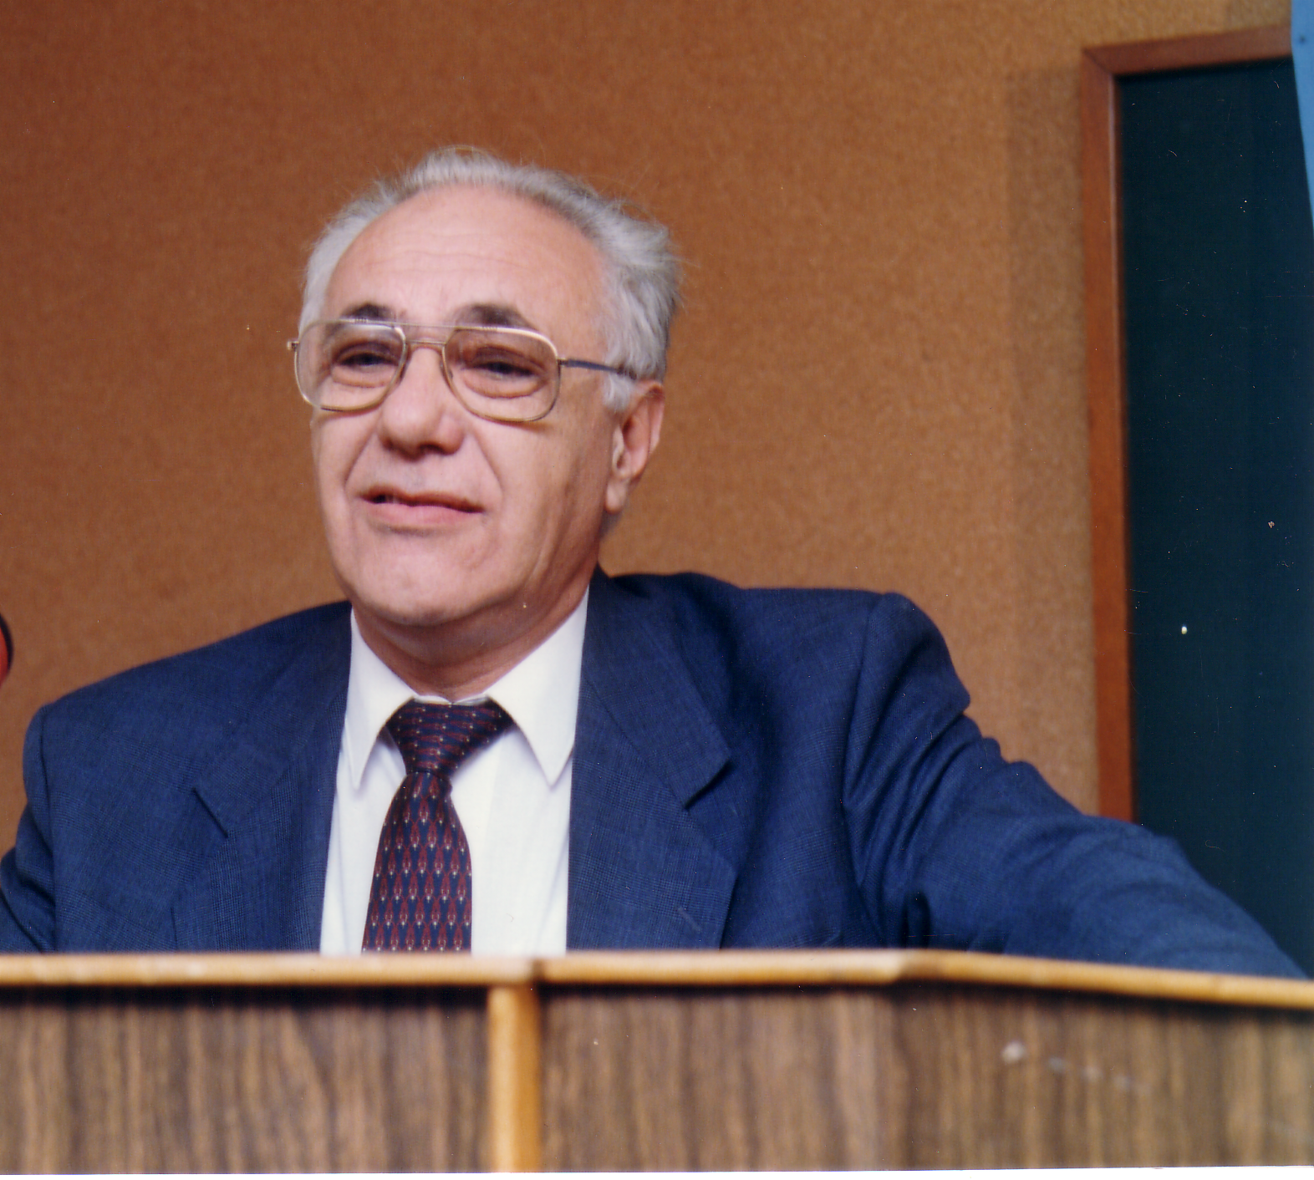

Together with the IMO Secretary-General of the time, HE Dr C.P. Srivastava, Dr Fenech was in more ways than one an architect of the Institute. He was a firm believer in the Institute as a project that could lead to improved awareness of the importance of the proper and adequate legal regulation of the oceans and of the human activities involving the oceans and their use. He also strongly advocated the training of human resources as a fundamental pillar for a better global legal order and for the growth of developing States. He unwaveringly pursued these noble aims and selflessly worked for the development and improvement of the Institute as a catalyst towards their attainment.

Dr Fenech was directly involved in establishing the Institute when, in 1988 as Parliamentary Secretary for Maritime and Other Affairs within the Ministry for Development of Tertiary Sector, he spear-headed the desire of the Maltese Government of the day to receive and host the Institute in Malta. His dynamic drive ensured that the Institute was housed within welcoming and well-equipped premises worthy of the lofty goals that were set for it. Over the years he was at the forefront of efforts to regularly upgrade the facilities made available to the Institute.

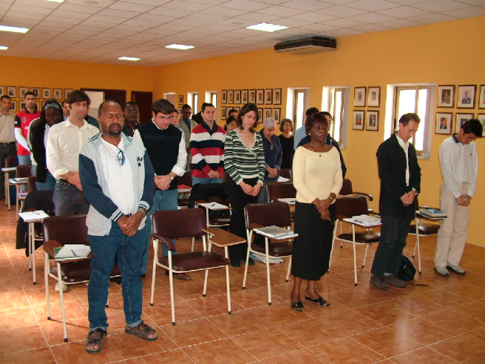

The 16th generation of IMLI lawyers paying tribute to Dr. Fenech with a minute of silence.

As a member of the Institute’s Governing Board ever since its establishment Dr Fenech also contributed directly and positively towards the well-being of the Institute and more importantly that of its students.

The Institute is a monument to the altruism, commitment and dedication of Dr. Fenech and others who like him and with him were blessed with a unique vision.

The Institute would take this opportunity to express its condolences to Dr. Fenech’s family.

_______________________

* For further information please contact Mr. Mitja Grbec (Editor, IMLI-e-News) at
publications@imli.org

** Should you wish to be removed from our mailing list, please send an email to
publications@imli.org

