Circulated in more than 100 States to personalities in the legal and maritime professions

IMLI e-News

The IMO International Maritime Law Institute Official Electronic Newsletter (Vol. 2, Issue No. 32) 21 April 2005

Consultant for International Law to the German Ministry:

“IMLI has developed a lot in the last couple of years”

Dr. Andree Kirchner, LL.M. (Stockholm) from Bremen (Germany) recently delivered a set of lectures at IMLI, as part of the IMLI Course on Marine Environmental Law. Dr. Kirchner is consultant for international law i.a. to the German Federal Ministry for Education and Research (Bonn/Berlin).

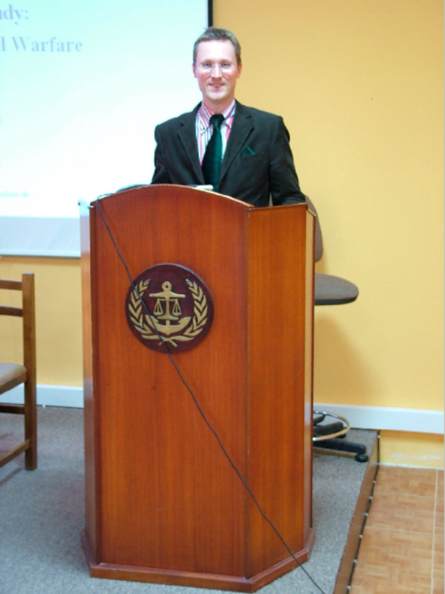

Dr. Andree Kirchner at IMLI.

Dr. Kirchner is a lecturer at the Master’s Programme in European and International Law at the University of Bremen and at the UNEP/UNESCO/BMU Centre for International Postgraduate Studies in Environmental Management in Dresden. He is specialized in the law of the sea and international marine environmental law.

During his lectures at IMLI, he introduced to IMLI students the intricacies of three interesting subjects from the field of international marine environmental law, namely “Environmental Protection in Time of Armed Conflict”, “Environmental Security” and “Marine Protected Areas”.

Dr. Kirchner, what were the highlights of your lectures at IMLI?

My lectures dealt with environmental security, marine protected areas, and furthermore, the topic of environmental protection in time of armed conflict. It was about showing a topic hardly known and seldom taught by lecturers, especially from a rather practical point of view. I included a video presentation and by case study (moot court) of a proceeding before the International Criminal Court (ICC). There was participation from both sides, from the lecturer and of course also from IMLI students.

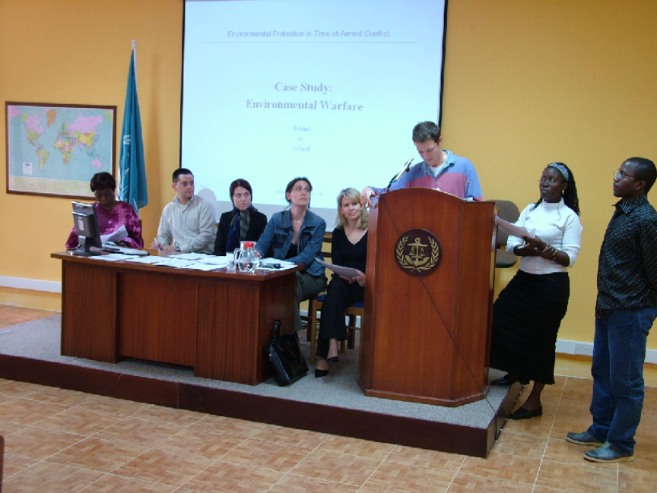

IMLI students during a “moot court” simulation

What are the latest development in the field of marine environmental law?

One of the latest developments is the proposal of “Marine protected areas beyond national jurisdiction”. The challenge faced by the international community in this regard is up to what extent does the question of international environmental protection collide with the freedoms of the high seas. This problem has recently been discussed by various international bodies, e.g. UNICPOLOS and CBD, which are trying to provide an answer to this difficult question.

What is your personal view about the establishment of marine protected areas and on the principle of the “freedoms of the High Seas” in general?

I am basically in favor of the establishment of “marine protected areas”. With regard the second part of your question my personal view is that the High Seas should have been included into the common heritage of mankind principle, rather than defining it as res communis. The freedoms of the high seas should be considered by a differentiated approach.

What are your general impressions about IMLI?

IMLI has definitely developed a lot in the last years in all aspects both with regard to material conditions (new premises, a completely new “multimedia” lecture room, a PC set in every student apartment) and to the structure of the organization as such. I appreciated very much the highly motivated participants (IMLI students). On a more personal basis I appreciated the warm welcome from the IMLI staff. It is a pleasure being here and I am looking forward to continue our cooperation.

___________________________________
* For further information please contact Mr. Mitja Grbec (Editor, IMLI e-News) at
publications@imli.org

** Should you wish to be removed from our mailing list please send an email to
publications@imli.org

