Circulated in more than 100 States to personalities in the legal and maritime professions

IMLI e-News

The IMO International Maritime Law Institute Official Electronic Newsletter

Secretary – General, IMO:
“Each graduating class provides significant benefits to the global maritime community”

On Saturday, 14 May 2005, the IMO International Maritime Law Institute (IMLI) held its 16th Graduation Ceremony. The Graduation Address was delivered by the Secretary - General of IMO and Chairman of the IMLI Governing Board, H.E. Mr. Efthimios Mitropoulos.

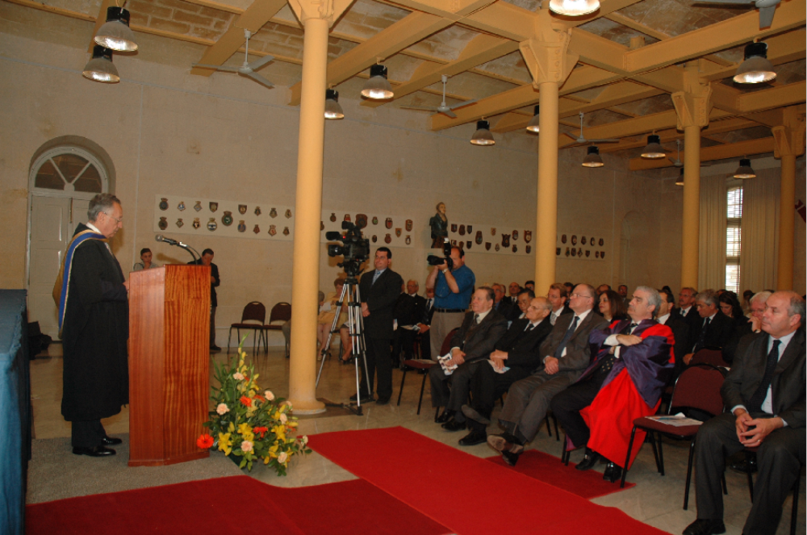
H.E. Mr. Efthimios Mitropoulos, (Secretary-General, IMO) delivering the Graduation Address at the 16th IMLI Graduation Ceremony.

GRADUATION ADDRESS BY H.E. MR. E.E. MITROPOULOS (SECRETARY-GENERAL, IMO):

Honourable Minister, Presidents Emeriti, Excellencies, Permanent Representatives of France and Malta to IMO, Governing Board Members, IMLI Faculty & Staff, Parents, Graduands, Distinguished Guests, Ladies and Gentlemen,

It is with great pleasure that I address you today at this year’s graduation ceremony at IMO’s International Maritime Law Institute.

I will start my speech by quoting from an address by United Nations Secretary-General Kofi Annan at the UN General Assembly last September when, emphasizing the importance of the rule of law, he spoke of the need for common solutions to the common problems that we all face today. I believe that his words are very relevant to all of us, in particular for the graduands’ work in the future. He stated that, “at the international level, all States – strong and weak, big and small – need a framework of fair rules which each can be confident that others will obey. Fortunately, such a framework exists. From trade to terrorism, from the law of the sea to weapons of mass destruction, States have created an impressive body of norms and laws. This is one of the United Nations’ proudest achievements”. Reminding his audience of our responsibility to protect innocent civilians by rigorously upholding international law, he even went on to suggest that History will judge us very harshly if we let ourselves be deflected from this task, or think we are excused from it, by invocations of various kinds.
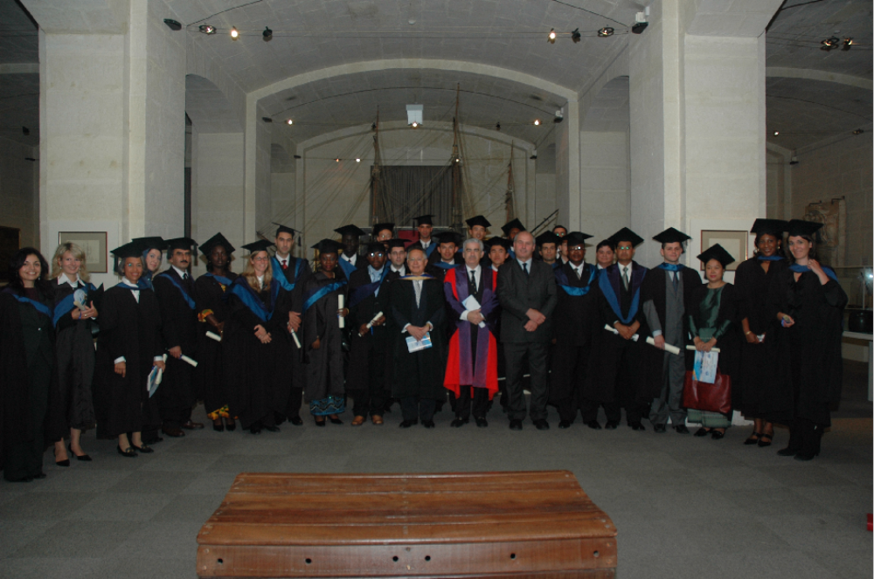
H.E. Mr. Efthimios Mitropoulos (Secretary-General, IMO) with Prof. David J. Attard (Director, IMLI), the Hon. Censu Galea (Minister for Competitiveness and Communications of Malta) and the 2005 IMLI Graduates.

As you know, at IMO, our efforts are concentrated on developing international standards aiming to enhance safety, security and protection of the marine environment, including compensation regimes for those who suffer loss when things go wrong. IMO instruments, in the form of conventions, protocols, codes, guidelines and recommended practices cover matters ranging from the design, construction and equipment of ships; the competence of the seafarers who man them; through safety management, the protection of the marine environment and the compensation of victims of pollution incidents to security-related issues like the prevention of piracy and armed robbery against ships and, most recently, our work to develop a comprehensive maritime security regime for ships, companies and port facilities.

But the development of such a regulatory framework is only one side of the equation. The other is the highly specialized task of drafting the necessary practicable and enforceable national laws without which the internationally agreed standards simply could not be implemented and put into effect. Each piece of this comprehensive regulatory structure involving Governments and all other stakeholders both at the international and national levels, contributes towards the overall sustainability of shipping, as an international industry which provides the facilitation mechanism for more than 90 percent of world trade. The effective global implementation of IMO’s instruments is a task for Governments, maritime administrations and the shipping industry itself and it is a testimony to the highly responsible stance adopted by them all that statistics demonstrate that safety at sea is improving and marine pollution reducing. But we cannot rest on our laurels as there is always more to be done.

In 1989, IMO established IMLI to provide the international maritime community, and particularly maritime administrations, with the support considered necessary to ensure that sufficient maritime law experts with the requisite knowledge and skills were available to develop national legislation to give effect to international instruments to which Governments had become Parties. The role of IMLI’s graduates as maritime law specialists in taking on this task, and probably many others in the future, cannot be over-emphasized. The responsibility for managing the legal framework and to ensure that quality shipping prospers, depends in large measure on the knowledge and professional skills of lawyers such as those graduating today.

One of IMO’s most significant tasks is to help develop the necessary human and organizational capacity needed to create effective maritime administrations capable of implementing the various IMO treaties and other instruments and thus enhance the ability of IMO Member Governments to realize their maritime aspirations. To date, IMLI’s impact on this aim can be measured by the undeniable success of its graduates around the world, as they have consistently secured senior positions in government administrations worldwide and within the global maritime industry – positions ranging from ministers of justice, attorneys general, chief justices, ambassadors, chief executives and senior corporate managers. I am confident that those graduating today, too, will, in due course, join their compatriots in these decisive career paths, even higher than those, and play their part in contributing to a safer, more secure and environment-friendly world of shipping.

IMLI’s success over the years would not have been achieved without the enduring support received from donors who have contributed either to the Institute’s general fund or through the provision of fellowships, and I would like to take this opportunity to express my thanks to them, in particular to the European Union, the Government of Switzerland, the Nippon Foundation and the Lloyd’s Register of Shipping, for their most valuable assistance. I look forward to a continuation of this vital source of aid and am confident that the consistently high quality of IMLI graduates will encourage more development partners and recipient countries to contribute to the excellent training that is being offered here in Malta. None of this would be possible without the generous hostship facilities provided by the Government of Malta and the continued support of the Malta Maritime Authority – I offer them both my sincere thanks for all these and, also, for the contribution of Malta, as one of the world’s major registers and an IMO Council Member, to the overall work of the Organization. Malta’s contribution to the development of the Law of the Sea in its present form is recognized worldwide making the country a most fitting place to host the Institute.

At this juncture, I would also like to take the opportunity to pay a very special tribute to Dr. Joseph Fenech, who sadly passed away recently. Advocating the training of human resources as a fundamental pillar for a better global legal order, it was Dr. Fenech who spear-headed the drive for Malta to host the Institute; and unwaveringly pursued his noble aims. As an IMLI Governor and a Visiting Lecturer, he worked selflessly for IMLI’s improvement as a catalyst for change. He is already missed.

I cannot close my remarks without offering my sincere appreciation and gratitude to IMLI’s many visiting lecturers, all of whom give their time and services voluntarily and generously. Their contribution in imparting invaluable knowledge and expertise to present and future generations is greatly appreciated by both students and the shipping industry. My thanks also go to the dedicated teaching and administrative staff of the Institute so ably led by the Institute’s Director, Professor David Attard; and, of course, my associates in the IMO Secretariat who assist the Institute in many ways. The Governing Board does an excellent job in dealing with the financial and academic affairs of the Institute and deserves every recognition and appreciation; as does my predecessor, Mr. O’Neil, from whom I inherited a well-set Institute and a heavy legacy to preserve. The contribution of the Academic Committee and the Comité Maritime International also merit a special mention.

The increasing number of IMLI graduates confirms the Institute’s effective capacity-building role within the maritime community and the shipping industry at large.

Each graduating class adds its knowledge and expertise to an already impressive network of alumni and provides significant benefits to the global maritime community.

In closing, I would like to address you, the class of 2005. I offer you firstly my congratulations for successfully reaching the end of your studies. And secondly, I welcome the addition of 29 students from 21 countries to the list of those who have graduated from IMLI. You join a formidable international network of 332 IMLI graduates from 103 States and territories, an impressive record indeed.

In a changing world, there are wonderful opportunities for those with the motivation and the willpower to make a difference to the world they live in. I feel sure that your time here in Malta has prepared you to play your part. You are on the threshold of joining the wonderful family of maritime lawyers and administrators who shape the policies and strategies of your respective countries; and, when your time comes, shape, through IMO, the regime that regulates shipping engaged in international trade.

You have a great role to play and a heavy duty to bear as you leave these shores. IMLI, whose flag you should always fly with pride, distinction and dignity, has equipped you with what you will need for a distinguished career in a most noble community – the international maritime community. The degree you are receiving today represents the fruit of your labour over the past year but it also marks the beginning of a new stage in the challenging career you have chosen. A career which will benefit yourselves, your families, your countries and the international maritime community as a whole. The future is yours and I envy you.

All that is left for me to do now, on this prestigious occasion, is to wish you all good luck and every success and I look forward to meeting you again in your future roles as you apply the specialized knowledge you have acquired in this Institute in pursuit of IMO’s desired goals of safe, secure, environmentally-friendly and efficient shipping on clean seas. Your countries need you and IMO will welcome you.

Ladies and Gentlemen, thank you.

________

