Circulated in more than 100 States to personalities in the legal and maritime professions

IMLIe-News

The IMO International Maritime Law Institute Official Electronic Newsletter        (Vol. 6, Issue No. 1)  5  September  2008

**IMLI ANNOUNCES THE COMMENCEMENT OF ITS  20 TH ANNUAL LL.M. PROGRAMME**

The IMO International Maritime Law Institute (IMLI), which was established in 1989 under the auspices of the International Maritime Organization (IMO), announces the commencement of its 20h Annual LL.M. programme.

The LL.M. programme for the academic year 2008 – 2009 will commence on Tuesday, September 9, 2008. It is expected that 37 lawyers from 24 States will pursue their LL.M. studies during this academic year. Costa Rica is going to be represented for the first time in the Institute’s LL.M. programme.

The  new academic year is marked by the increased participation of women who represent the two - third of the student  body. This is an achievment of the aim of the Institute Founders who sow it fit to provide in the IMLI Statute that "to encourage equitable participation by women, 50 per cent of the places in each regular course of the Institute shall be reserved for women candidates, provided that the necessary numbers of women candidates with the required entrance qualifications are available for each particular course".

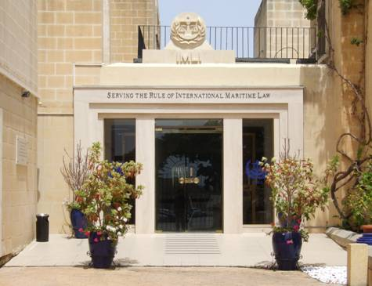

# IMLI STUDENTS OF THE YEAR 2008 – 2009

|  |  |  |
| --- | --- | --- |
| Mr. Youcef Ramdane | Algeria | Algerian Navy |
| Mr. Abderrazak Titraoui | Algeria | SAFEMED |
| Ms. Anisabel de Campos Verissimo  e Costa | Angola | Ministry of Justice of Angola |
| Ms. Vezua Bula Diogo de Paiva | Angola | Ministry of Justice of Angola |
| Mr. Farhad Mammadov | Azerbaijan | NIPPON Foundation |
| Ms. Kenia Marie Tuere Nottage | Bahamas | Self-Financed |
| Ms. Melisa Simone Wright-Knowles | Bahamas | NIPPON Foundation |
| Mr. Feng Jianzhong | China | NIPPON Foundation |
| Ms. Paola Acuña Chacón | Costa Rica | Lloyd’s Register |
| Ms. Kathy Rowena Buffong | Dominica | NIPPON Foundation |
| Mr. Ibrahim Ahmed Ibrahim El Diwany | Egypt | SAFEMED |
| Mr. Zaza Pirveli | Georgia | NIPPON Foundation |
| Ms. Amanza Walton-Desir | Guyana | IMO |
| Mr. Samuel Darse | India | NIPPON Foundation |
| Mr. Unni Ramachandran | India | Self-Financed |
| Ms. Renny Meirina | Indonesia | NIPPON Foundation |
| Mr. Eyad Ahmad Ali Al-Zoubi | Jordan | IMO |
| Mr. Choe Kun Song | DPR Korea | IMO |
| Mr. Jo Se Gwan | DPR Korea | IMO |
| Ms. Primrose Aprodite Chimwaza | Malawi | IMO |
| Ms. Jessica Curmi | Malta | Waiver |
| Ms. Alison Gili | Malta | IMO Partial Scholarship |
| Mr. Matthew Xerri | Malta | Waiver |
| Ms. Adeola Jemima Shona | Nigeria | NIMASA |
| Ms. Bukola Adenike Iyelolu | Nigeria | NIMASA |
| Ms. Lilian Njideka King-Chibuzor | Nigeria | Nigerian Shippers’ Council |
| Ms. Margaret Kingsley Williams | Nigeria | Akwa Ibom State Government |
| Mr. Nwaohiri Keneth Ikechukwu | Nigeria | Nigerian Ports Authority |
| Ms. Ruth Malafa | Nigeria | NIMASA |
| Mr. Shafiq Ur Rahman | Pakistan | Pakistan Navy |
| Ms. Jana Rodica | Slovenia | Self-Financed |
| Ms. Katja Pecek | Slovenia | Lloyd’s Register |
| Ms. Shireen Anusha Fernando | Sri Lanka | NIPPON Foundation |
| Ms. Agatha Monica James-Andries | St. Kitts and Nevis | Lloyd’s Register |
| Ms. Jennifer Pelosi | Switzerland | Self-Financed |
| Ms. Tran Thi Hai Yen | Viet Nam | NIPPON Foundation |

*___________________________________*

* *If you do not want to receive IMLI e-News in future, please return this message to the above address with request to DELETE in the subject field.*

*\*\* For further information please contact Ms. Elda Belja (Editor, IMLI e-News) at* [publications@imli.org](mailto:publications@imli.org)