Circulated in more than 100 States to personalities in the legal and maritime professions

IMLIe-News

The IMO International Maritime Law Institute Official Electronic Newsletter       (Vol.  6,  Issue No. 11)   7 November  2008

OXFORD UNIVERSITY PROFESSOR DELIVERS IMLI’s ANNUAL COURSE ON CARRIAGE OF GOODS BY SEA

Professor Francis M. B. Reynolds (Q.C. (Hon.), Barrister, Professor Emeritus, University of Oxford) is currently delivering a series of lectures on the “Carriage of Goods by Sea”, which is one of the key subjects within IMLI’s Shipping Law curriculum.

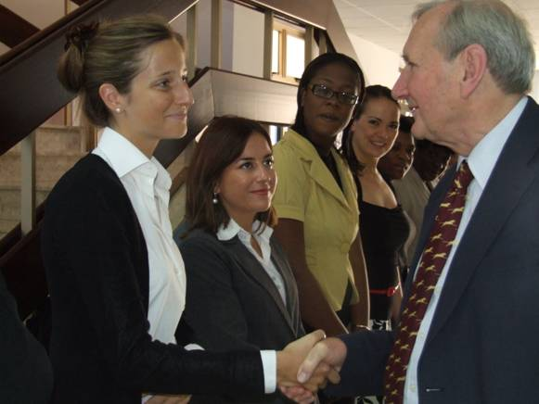

*Professor Francis M. B. Reynolds meeting students of IMLI class 2008/2009.*

*From left to right: Ms. Jennifer Pelosi (Switzerland), Ms. Jessica Curmi (Malta), Ms. Amanza Walton-Desir (Guyana), Ms. Katja Pecek (Slovenia), Ms. Primrose Chimwaza (Malawi), Ms. Agatha James-Andries (St. Kitts and Nevis)*

Professor Reynolds’ lectures offer a comprehensive course on Carriage of Goods by Sea, with a special focus on the problems relating to charterparties and bills of lading that commonly arise. The students are given an opportunity to gain a detailed understanding of the obligations and rights arising from bills of lading and charterparty contracts, as the course examines a comprehensive list of topics including the nature and functions of the bills of lading and other transport documents, rights and liabilities pertaining to different types of charterparties, as well as the relationship between the charter, the bill of lading and other transport documents. In his lectures Prof. Reynolds places the subject of the Carriage of Goods by Sea in the broader context of international trade, touching on the topics such as contracts of international sale of goods and the role of banks in the facilitation of financing arrangements for the international sale of goods. The lectures are enriched by a number of practical examples based on actual disputed law cases and real commercial documents.

Prof. Reynolds is a Professor Emeritus of Oxford University. He is a Fellow of the British Academy, a Titulary Member of the Comité Maritime International, and formerly a Visiting Professor at University College London, University of Auckland, University of Sydney, University of Melbourne, The University of Hong Kong, Monash University and The National University of Singapore. He has been a visiting lecturer at IMLI for more than 10 years and his longstanding academic support to the IMO International Maritime Law Institute is of an immense value and importance.

__________________________________________________________________________

* *If you do not want to receive IMLI e-News in future, please return this message to the above address with request to DELETE in the subject field.*

*\*\* For further information please contact Ms. Elda Belja (Editor, IMLI e-News) at* [publications@imli.org](mailto:publications@imli.org)