Circulated in more than 100 States to personalities in the legal and maritime professions

IMLIe-News

The IMO International Maritime Law Institute Official Electronic Newsletter          (Vol.  6 , Issue No. 12)   14 November 2008

The IMO International Maritime Law Institute Official Electronic Newsletter (Vol. 4, Issue No. 2) 18 September 2006

**REMPEC’S SAFEMED PROJECT OFFICER LECTURES AT IMLI**

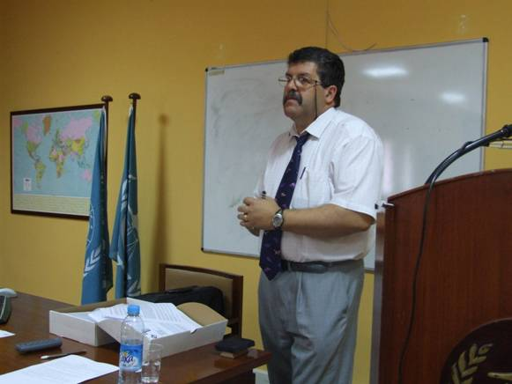

## Captain Joseph Zerafa during his lecture to the IMLI class of 2008-2009

Captain Joseph Zerafa recently visited the Institute to deliver two lectures on the *“Technical Aspects of Shipping”* to the 20th generation of IMLI lawyers. With the aim of giving the students a general overview of the technical terminology used in the construction and operation of ships, Captain Zerafa’s lectures focused on technical matters relating to ship construction, stability and compliance with international regulations.

Captain Zerafa joined the Regional Marine Pollution Emergency Response Centre for the Mediterranean Sea (REMPEC) in 2006 as the “Euro-med Cooperation on Maritime Safety and Prevention of Pollution from Ships – SAFEMED” (SAFEMED) Project Officer in Maritime Safety. Prior to that, Captain Zerafa worked with the Malta Maritime Authority as the Technical Manager within the Merchant Shipping Directorate. In this capacity, he was responsible for setting up and running the Safety Co-Ordination Unit including Flag State and Port State Control inspections, casualty investigations and monitoring of Recognized Organizations. Captain Zerafa also represented Malta at international fora, including the IMO committees and sub-committees, PARIS MoU meetings and EU Technical meetings.

SAFEMED is an EU-funded project implemented by REMPEC. The SAFEMED project seeks to mitigate the imbalance in the application of maritime legislation in the region among Mediterranean partners who are not members of the European Union (EU) and those who are, by promoting a coherent, effective and uniform implementation of the relevant international conventions aimed at better protection of the marine environment in the Mediterranean.

The SAFEMED project provides 10 scholarships to qualified, government-nominated IMLI students coming from the Mediterranean partners of Algeria, Egypt, Israel, Jordan, Lebanon, Morocco, the Palestinian Authority, Syria, Tunisia and Turkey. The scholarships granted under the Project are intended to further the Institute's role in improving the training opportunities for specialist lawyers, particularly legal personnel employed by governmental institutions working in the field of maritime affairs. This year’s SAFEMED scholars are: Mr. Saber Fayiz Fahmi Alaiwah (Jordan), Mr. Ibrahim Ahmed El Diwany (Egypt) and Mr. Abderrazak Titraoui (Algeria).

*___________________________________*

* *If you do not want to receive IMLI e-News in future, please return this message to the above address with request to DELETE in the subject field.*

*\*\* For further information please contact Ms. Elda Belja (Editor, IMLI e-News) at* [publications@imli.org](mailto:publications@imli.org)