Circulated in more than 100 States to personalities in the legal and maritime professions

IMLIe-News

The IMO International Maritime Law Institute Official Electronic Newsletter          (Vol.  6 , Issue No. 13)   21 November 2008

The IMO International Maritime Law Institute Official Electronic Newsletter (Vol. 4, Issue No. 2) 18 September 2006

**IMO FACILITATION COMMITTEE CHAIRMAN LECTURES AT IMLI**

Mr. Charles Abela, Chairman of the International Maritime Organization’s (IMO) Facilitation Committee, recently visited the Institute to deliver two lectures on “International Maritime Trade” and the “Facilitation Convention” to the 20th generation of IMLI lawyers.

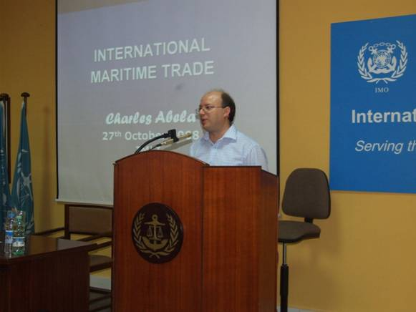

*Mr. Charles Abela during his lecture to the IMLI class 2008/2009*

His lecture on “International Maritime Trade” focused on the economic argument for international trade, the historical development of maritime trade, the shift in productive countries, the increase in global corporations as a result of globalisation, and the important role of shipping in international trade.

Referring to IMO’s 60 Years in the Service of Shipping Mr. Abela quoted from the Maritime Knowledge Centre 2008 that “*We live in a global society supported by a global economy, and that economy simply could not function if it were not for ships and the shipping industry. Shipping is truly the lynchip of the global economy: without shipping, intercontinental trade, the bulk transport of raw materials and the import/export of affordable foods and manufacture goods would simply not be possible”.*

His second lecture on the “Facilitation Convention” dealt with the reasons for facilitation of international maritime traffic in order to simplify and minimise formalities, documentary requirements, and procedures, how can such facilitation be achieved and the reasons for developing the “Facilitation Convention”. Mr. Abela then provided an overview of the “Facilitation Convention”.

Mr. Abela obtained his B.A. (Hons.) in Business Management, at the University of Malta and his M.Sc. in Ports and Shipping Administration at the World Maritime University in Malmo, Sweden.

Since 1996 he is the Ports Deputy Executive Director, Malta Maritime Authority.

He is the Chairman of IMO’s Facilitation Committee, Chairman of Malta Shortsea Promotion Centre and Chairman of Port Workers Board.

*___________________________________*

* *If you do not want to receive IMLI e-News in future, please return this message to the above address with request to DELETE in the subject field.*

*\*\* For further information please contact Ms. Elda Belja (Editor, IMLI e-News) at* [publications@imli.org](mailto:publications@imli.org)