Circulated in more than 100 States to personalities in the legal and maritime professions

IMLIe-News

The IMO International Maritime Law Institute Official Electronic Newsletter       (Vol.  6, Issue No.15) 5 December 2008

**INSTITUTE OF CHARTERED SHIPBROKERS’ FELLOW LECTURES AT IMLI**

Mr. Godwin Xerri, Fellow of the Institute of Chartered Shipbrokers and Managing Director of Focal Maritime Services Co., Ltd. Malta, is delivering a series of lectures on Management and Operation of Ships, Charterparties and Documentation, and Proprietary Interests on Ships.

Drawing from his considerable experience, Mr. Xerri through his lectures explains the commercial practices and procedures for the sale and purchase of second hand ships. During his presentations, enriched by his practical knowledge and experience, he puts into perspective the commercial considerations and decision taking in the context of ship management, operation and chartering. Mr. Xerri also stresses that it should be always remembered that shipping is in continuous development and does not operate in isolation but in an environment with plenty of interaction amongst the various subjects of commerce and in particular amongst the many players involved in the transport chain.

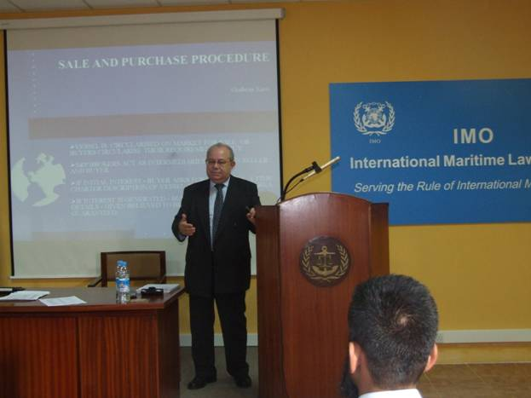

*Mr. Godwin Xerri lecturing to the IMLI Class of 2008/2009*

Mr. Godwin Xerri is a longstanding supporter and friend of the Institute. His lectures bring the touch of practice from the shipping markets directly to the classroom.

*___________________________________*

* *If you do not want to receive IMLI e-News in future, please return this message to the above address with request to DELETE in the subject field.*

*\*\* For further information please contact Ms. Elda Belja (Editor, IMLI e-News) at* [publications@imli.org](mailto:publications@imli.org)