Circulated in more than 100 States to personalities in the legal and maritime professions

IMLIe-News

The IMO International Maritime Law Institute Official Electronic Newsletter       (Vol.  6 , Issue No. 16)    12 December 2008

**DPR KOREA DELEGATION VISITS IMLI**

On 9 December 2008, a delegation from the DPR Korea Maritime Administration headed by Mr. Jon Ki Chol, Deputy Director-General, paid a courtesy visit to the Institute. They were welcomed by the Director, Professor David Attard who recognized the importance of the relationship between DPR Korea and IMLI and the key role those students enrolling the LL.M programme play to the further strengthening of these relationships. Professor Attard then introduced them to the students of IMLI class 2008 – 2009.

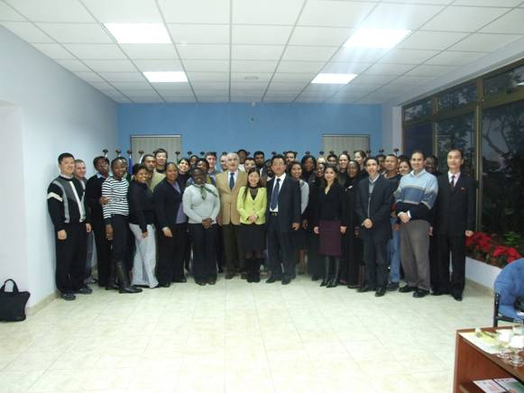

*Mr. Jon Ki Chol, Professor David Attard and IMLI class 2008/2009*

Mr. Jon Ki Chol thanked Professor Attard and the students for their welcome and acknowledged the great role IMLI plays in the development of international maritime law. Mr. Jon Ki Chol stated, *inter alia*, that:

*“The full and effective implementation of IMO Conventions and Protocols is guaranteed by national maritime laws. In this respect, IMLI has a very important mission. Indeed, we are very impressed by IMLI’s activities and we are fully confident of its further growth and development”.*

This academic year DPR Korea is represented by Mr. Jo Se Gwan and Mr. Choe Kun Song.

_________________________________

* *If you do not want to receive IMLI e-News in future, please return this message to the above address with request to DELETE in the subject field.*

*\*\* For further information please contact Ms. Elda Belja (Editor, IMLI e-News) at* [publications@imli.org](mailto:publications@imli.org)