Circulated in more than 100 States to personalities in the legal and maritime professions

IMLIe-News

The IMO International Maritime Law Institute Official Electronic Newsletter       (Vol.  6 , Issue No. 18)    26 December 2008

**SEASONAL GREETINGS**

Professor David Attard, IMLI Director, Faculty Members and Staff wish you a Merry Christmas and a Happy New Year 2009.

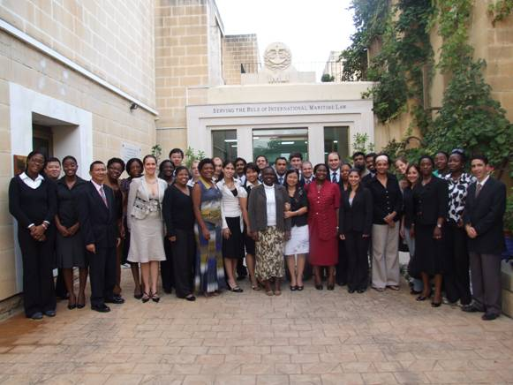

*IMLI class 2008/2009*

_________________________________

* *If you do not want to receive IMLI e-News in future, please return this message to the above address with request to DELETE in the subject field.*

*\*\* For further information please contact Ms. Elda Belja (Editor, IMLI e-News) at* [publications@imli.org](mailto:publications@imli.org)