Circulated in more than 100 States to personalities in the legal and maritime professions

IMLIe-News

The IMO International Maritime Law Institute Official Electronic Newsletter       (Vol.  6, Issue No. 19) 02 January 2009

**DAVID MARTIN-CLARK LECTURES AT IMLI**

Recently the Institute had the honour of hosting Mr. David Martin-Clark as a visiting lecturer. Mr. Martin-Clark lectured on UNCITRAL Draft Convention on Carriage of Goods (wholly or partly) by Sea and on Electronic Commerce in the context of shipping.

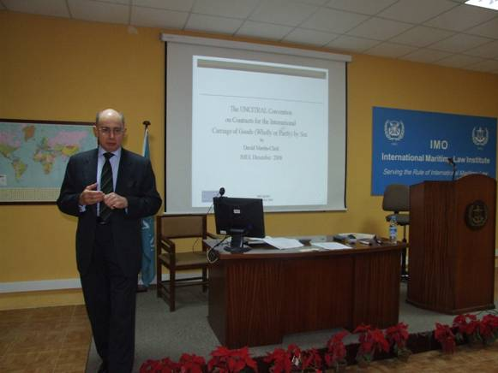

*Mr. David Martin-Clark lecturing to the IMLI class 2008-2009*

Mr. Martin-Clark gave a detailed explanation of the UNCITRAL Draft Convention on Carriage of Goods (wholly or partly) by Sea covering issues such as its scope of application, the period of carrier’s responsibility, the nature/extent of carrier’s responsibility, who is the performing party, what are the liabilities for delay, the shipper’s responsibilities, delivery, and jurisdiction & arbitration.

In his second lecture Mr. Martin-Clark dealt with Electronic Commerce in the context of shipping during which he discussed the Legal Infrastructure of Electronic Commerce with special focus on the European Model EDI Agreement, the UNCITRAL Model Law on Electronic Commerce, the UNCITRAL Model Law on Electronic Signatures, the UNCITRAL Convention on the Use of Electronic Communications in International Contracts and the Electronic Commerce and Transport Documents (the Bill of Lading).

Mr. Martin-Clark was Educated at Dulwich College and Magdalen College, Oxford where he obtained a Law degree (1st Class Honours). He is a Barrister-at-Law in general commercial advisory practice, specialising in shipping, transport and insurance, particularly mutual insurance. As an Arbitrator he is a member of a number of internationally recognised associations of arbitrators. Mr. Martin-Clark is also accredited as a Mediator by Centre for Effective Dispute Resolution (CEDR). He works as a Consultantin Shipping, Transport and Insurance affairs and is the Director of London Shipping Law Centre.

During his earlier career he was employed for more than thirty years by the Thomas Miller Group, within which he occupied a number of high positions as Chairman and Chief Executive of the Miller Holding Company, as Chairman and Director of its subsidiaries in the UK, Hong Kong, Singapore, Australia and the US and as Senior Partner of both its on-shore and off-shore partnerships. He led the development of the Through Transport Mutual Insurance Association (the 'TT Club').

He is the editor of DMC's CaseNotes, a Legal Case Notes Website ([www.onlinedmc.co.uk](http://www.onlinedmc.co.uk)) for Industry and Professionals, Lawyers and other Advisers, and Students.

_________________________________

* *If you do not want to receive IMLI e-News in future, please return this message to the above address with request to DELETE in the subject field.*

*\*\* For further information please contact Ms. Elda Belja (Editor, IMLI e-News) at* [publications@imli.org](mailto:publications@imli.org)