Circulated in more than 100 States to personalities in the legal and maritime professions

IMLIe-News

The IMO International Maritime Law Institute Official Electronic Newsletter     (Vol. 6, Issue No. 2)  12  September  2008

**IMLI WELCOMES THE 20TH GENERATION OF LAWYERS TO PARTICIPATE IN THE LL.M. PROGRAMME**

The IMO International Maritime Law Institute (IMLI) inaugurated on September 9, 2008 its 20th Annual LL.M. Programme and welcomed a new generation of lawyers.

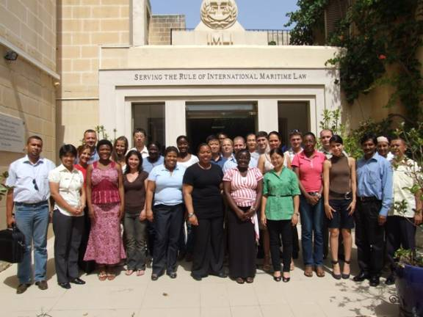

Since the establishment of IMLI, 428 lawyers from 112 States and territories around the world have been awarded the Institute's degree of Master of Laws in International Maritime Law (LL.M.).  IMLI graduates are today greatly contributing to the goals of IMO and the needs of their States. Currently, IMLI’s graduates around the world have secured senior positions in Government administrations, often representing their countries at IMO meetings, and also within the global shipping and port industries - positions ranking from Ministers of Justice, Chief Justices, Attorneys-General, Ambassadors, Judges, chief executives and senior corporate managers.

The new IMLI intake represents 23 States, with Costa Rica sending her representative to IMLI for the first time.

During this academic year the following students are going to attend IMLI's 4th Advanced Diploma Programme:

**Mr. Emanuel Mallia,** Staff Officer 1 OPS, INT, Plans and Training, Armed Forces of Malta, Malta

**Mr. Clinton O’ Neill**, Captain, Armed Forces of Malta, Malta

**Mr. Edric Zahra,** Captain, Armed Forces of Malta, Malta,

**Mr. Achiri Devine Fru, Legal Consultant, Cameroon**

*___________________________________*

* *If you do not want to receive IMLI e-News in future, please return this message to the above address with request to DELETE in the subject field.*

*\*\* For further information please contact Ms. Elda Belja (Editor, IMLI e-News) at* [publications@imli.org](mailto:publications@imli.org)