Circulated in more than 100 States to personalities in the legal and maritime professions

IMLIe-News

The IMO International Maritime Law Institute Official Electronic Newsletter       (Vol.  6, Issue No. 20) 09 January 2009

**BRAZILIAN EMINENT PROFESSOR LECTURES AT IMLI**

IMLI had the honour to host a lecture by Prof. Osvaldo Agripino on Wednesday 7th January 2009. Professor Agripino’s lecture dealt with a comparative analysis of the regulations of maritime transportation and ports of the United States of America and Brazil.

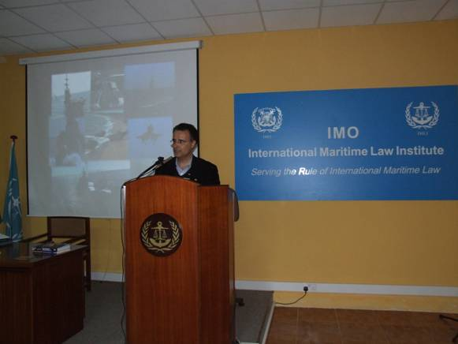

*Prof. Osvaldo Agripino lecturing to the IMLI class 2008/2009*

In the first part of his lecture, Professor Agripiono provided a comparative analysis of Aviation transportation with special focus on the US Federal Aviation Administration (FAA, 1958) and the Brazilian Agência Nacional de Aviação Civil (ANAC, 2005). His second part was dedicated to a comparisim of maritime transportation and harbours with special reference to the US Federal Maritime Commission (FMC, 1961) and the Brazilian Agência Nacional de Transportes Aquaviários (ANTAQ, 2001).

Professor Agripino is a Professor of Regulation Law of Transportation and Harbours and Maritime Law in the Master and PhD Law Program at UNIVALI and Getulio Vargas Foundation, Rio de Janeiro, Brazil.

He was Deck Officer of Brazilian Merchant Marine (1983/1987), where travelled to 27 countries in the most important Brazilian shipping companies, such as: Vale do Rio Doce Navegação, Petrobrás (Transpetro), Frota Oceânica and Libra.

Professor Agripino graduated in 1983, in Nautical Sciences (Brazilian Merchant Marine Academy/RJ) and in 1992 he obtained his Law Degree from the University of State of Rio de Janeiro. He has an LLM in Constitutional Law (Catholic University, PUC/RJ, 1996), a PhD in International Law in 2001 (CPGD-UFSC), Visiting Scholar at Stanford Law Schooland Post-Doctorate in Comparative Regulation of Transportation and Harbours, in the Centre for Business and Government of the John Kennedy School of Government–Harvard University–2007/2008, sponsored by the Brazilian Government (CAPES).

He is a Lawyer and Legal consultant in transports, international trade and ports. Professor Agripino is the Author and co-author of more than 30 books and legal papers.

Professor Agripino donated to IMLI three books, namely: Direito Maritimo made in Brazil with 20 articles on Maritime Law, Direito Regulatório e Novação nos Transportes e Ports nos Estados Unidos e Brasil and a Dictionary about International Trade Terms in English and Portuguese.

_________________________________

* *If you do not want to receive IMLI e-News in future, please return this message to the above address with request to DELETE in the subject field.*

*\*\* For further information please contact Ms. Elda Belja (Editor, IMLI e-News) at* [publications@imli.org](mailto:publications@imli.org)