Circulated in more than 100 States to personalities in the legal and maritime professions

IMLIe-News

The IMO International Maritime Law Institute Official Electronic Newsletter       (Vol.  6 , Issue No. 21) 16 January 2008

**PROFESSOR OF COMMERCIAL, TRANSPORT AND INSURANCE LAW OF THE UNIVERSITY OF LJUBLJANA LECTURES AT IMLI**

Recently, Prof. Dr. Marko Pavliha, Professor of Commercial, Transport and Insurance Law at the University of Ljubljana, Faculty of Maritime Studies and Transportation, Former Minister of Transportation and Deputy Speaker of the Republic of Slovenia, delivered a course on the Law of Marine Insurance to the IMLI class of 2008/2009, in Malta. This is the tenth academic year that Prof. Pavliha delivers the course on the Law of Marine Insurance as one of the fundamental parts of the Shipping Law curriculum of IMLI’s LL.M. programme. The purpose of the course is to give the students an overview of marine insurance, its history, functioning of insurance markets and basic understanding of the main principles and concepts of marine insurance law, including also some basic analysis of the broadly used standard clauses of marine hull and machinery insurance and cargo insurance.

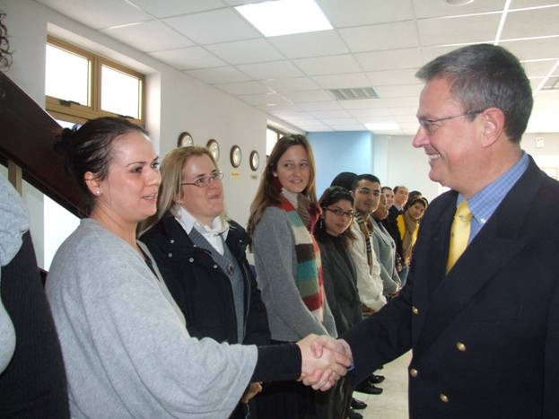

*Prof. Dr. Marko Pavliha meeting students of  IMLI class of 2008/2009 (from the left to right: Ms. Katja Pecek (Slovenia), Ms. Jana Rodica (Slovenia), Ms. Jennifer Pelosi (Switzerland), Ms. Alison Gili (Malta), Mr. Farouq Al-Bdour (Jordan))*

In a short interview (reproduced below) he expressed his views with regard to his long experience as a visiting lecturer, the growth of the Institute and the factors that contributed to the latter.

**Professor Pavliha, you have been delivering the course on the Law of Marine Insurance to the IMLI students for 10 years now. How do you find the experience?**

It is a wonderful experience. I enjoy it every year as much as the first year, maybe even more. It is different when you start something new. I still remember my stage fear the first time I was addressing such a diverse class of students coming from different countries.

Having been around for 10 years now, I am strongly convinced that IMLI is a unique place. To me IMLI is the actual embodiment of the inter-cultural dialogue as it brings together different cultures, legal systems, languages and religions.

**After all these years do you notice any changes or developments be it at institutional level and/or in the student body?**

One may notice the incredible progress IMLI has made during these years in term of premises, facilities, library etc, which contribute to make life and studies for the students much easier and comfortable.

It would be unfair to compare different generations, but the truth is that, because of the globalization and development of the technology, especially internet, students are each year more demanding.

**What in your opinion contributed to the lack of an international regime on Marine Insurance?**

There have been several attempts to draft a model law on Marine Insurance or even an International Convention, but all of them have failed. The only logical conclusion is ‘do not fix it if it is working’ and the existing legal regime is actually working, although it is predominantly based in English Law.

**IMLI celebrates this year its 20th anniversary; notably this year is marked by the largest and most diverse student body (37 students from 24 countries) and the remarkable increase of women participants. What in your opinion contributed to such a development?**

It is the combination of various factors. IMLI’s reputation has grown tremendously world wide as a unique institute. As per the increased participation of women: the equality between men and women is a feature of today’s society. But, one must recognize that IMLI’s policy on reserving 50 per cent of its places to women participants has helped to such an increased participation. This policy is unique as unfortunately is not the case of most other educational institutions, not to mention other organizations, companies etc.

To conclude I would like to express my deepest gratitude to Professor Attard and IMLI’s staff for giving me the opportunity each year to come to Malta and lecture to such a prominent intellectual and international audience; or to express it with the words of a famous movie actor: “I’ll be back”.

_________________________________

* *If you do not want to receive IMLI e-News in future, please return this message to the above address with request to DELETE in the subject field.*

*\*\* For further information please contact Ms. Elda Belja (Editor, IMLI e-News) at* [publications@imli.org](mailto:publications@imli.org)