Circulated in more than 100 States to personalities in the legal and maritime professions

IMLIe-News

The IMO International Maritime Law Institute Official Electronic Newsletter       (Vol.  6 , Issue No. 22) 20 January 2008

**IMO INVITES GOVERNMENTS TO NOMINATE CANDIDATES FOR IMLI’S 21st LL.M. PROGRAMME**

On 7 January 2009 IMO circulated to all its Member States Circular Letter No. 2925 announcing IMLI’s 21st LL.M. Programme which is scheduled to commence on 9 September 2009.

The Letter (reproduced below) recalls that ‘*Designed as an intensive and specialized postgraduate programme for graduates in law, the programme includes an introduction to shipping, intensive education in maritime law and training in the drafting of maritime legislation. It has been recognized as a most effective way to assist developing countries in training their own nationals who would subsequently constitute the initial nucleus of a well-established capability in maritime law and in the drafting of maritime legislation, which is of paramount importance for the protection of the marine environment and the safe operation and development of the shipping and port industries.*’

Participation in the programme is offered on the widest possible geographical basis, but the number of admissions is limited due to the intensive nature of the programme. Accordingly, should nominations be made for two or more candidates from one country, it would be appreciated if a priority order could be indicated. Fifty per cent of admissions are reserved for suitably qualified women candidates.

For the timely selection and notification of candidates, **it is essential that the nomination form, application form and scholarship form, where applicable, reach the Institute by 27 February 2009**.  For any inquiries please contact the Institute at [admissions@imli.org](mailto:admissions@imli.org).

The application package for government-nominated and self-financed candidates including information about the Institute, admissions and application forms can be downloaded by accessing our website [www.imli.org](http://www.imli.org).

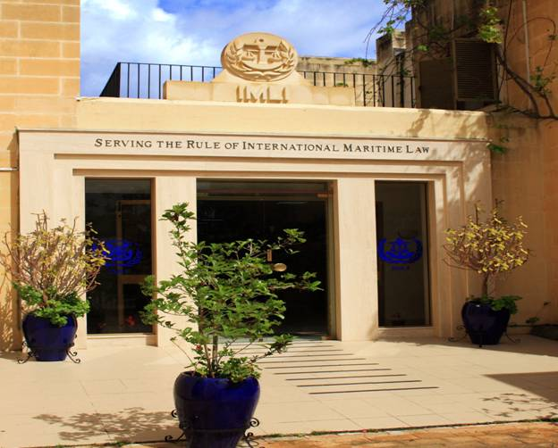

_________________________________

* *If you do not want to receive IMLI e-News in future, please return this message to the above address with request to DELETE in the subject field.*

*\*\* For further information please contact Ms. Elda Belja (Editor, IMLI e-News) at* [publications@imli.org](mailto:publications@imli.org)

|  |  |  |
| --- | --- | --- |
| **INTERNATIONAL MARITIME ORGANIZATION**  4 ALBERT EMBANKMENT  LONDON SE1 7SR  Telephone:            020 7735 7611  Fax:             020 7587 3210 | cid:image003.gif@01C97B0B.93206400 **IMO** | ***E*** |

Ref. TCD/2009/01                                                                                                                                Circular letter No.2925

7 January 2009

To:                          All IMO Member States

**Subject:               21st LL.M. Programme at the International Maritime Law Institute, Malta**

**9 September 2009 to May 2010**

1              The Secretary-General is pleased to announce that the 21st LL.M. Programme will be held at the International at the International Maritime Law Institute in Malta from 9 September 2009.

2              Designed as an intensive and specialized postgraduate programme for graduates in law, the programme includes an introduction to shipping, intensive education in maritime law and training in the drafting of maritime legislation. It has been recognized as a most effective way to assist developing countries in training their own nationals who would subsequently constitute the initial nucleus of a well‑established capability in maritime law and in the drafting of maritime legislation, which is of paramount importance for the protection of the marine environment and the safe operation and development of the shipping and port industries.

3              The Institute was established in Malta under the auspices of the International Maritime Organization with the generous provision of the premises and related facilities by the Government of Malta.

4              Detailed information on the programme syllabus and application procedures is attached in the “Application Package for Nominated Candidates for 2009‑2010”.

5              Nomination of candidates by the Government concerned should be made on the nomination form attached and all completed forms should be sent to IMLI directly.  For the timely selection and notification of candidates, **it is essential that the nomination form, application form and scholarship form, where applicable, reach the Institute by 27 February 2009**.  The selection of candidates will take place soon after that deadline and those selected will be informed accordingly by the Institute thereafter.

6              Participation is offered on the widest possible geographical basis, but the number of admissions is limited due to the intensive nature of the programme.  Accordingly, should nominations be made for two or more candidates from one country, it would be appreciated if a priority order could be indicated.  Fifty per cent of admissions are reserved for suitably qualified women candidates.

7              The programme fee is Euro €28,000 and the Nominating Authority is responsible for payment of the programme fees.  Where a fellowship is confirmed to be available, the Nominating Authority remains responsible for the payment of the Additional Funding Component.

8              Where financial assistance is required, the application form should be accompanied by the payment of a scholarship application fee of €200 in the form of a bank draft and a duly completed Scholarship Application Form.  This scholarship application fee is in addition to the application and processing fee of €50.  The scholarship application fee covers all administration costs incurred in approaching potential sponsors and seeking scholarship funding for the candidates.

9              The Secretary-General wishes to take this opportunity once again to express appreciation to the Government of Malta for its support.