Circulated in more than 100 States to personalities in the legal and maritime professions

IMLIe-News

The IMO International Maritime Law Institute Official Electronic Newsletter       (Vol.  6 , Issue No. 23) 26 January 2009

**BUREAU VERITAS LEGAL ADVISOR DELIVERS LAW OF MARITIME SAFETY COURSE AT IMLI**

Dr. Philippe Boisson, Communication Director and Legal Advisor of the Bureau Veritas Marine Division, delivered the course on the Law of Maritime Safety to the 20th IMLI lawyers’ generation.  The course, which is one of the key subjects of the Shipping Law curriculum of IMLI’s LL.M. programme, is an intensive one and its aim is to give a comprehensive overview of the international instruments providing for safety of shipping in all respects. Scheduled in seven lectures the course focuses on the regulatory process related to maritime safety, the ship safety, construction and equipment, cargo safety, the human element and operational safety, the control of ship safety and finally on the classification societies.

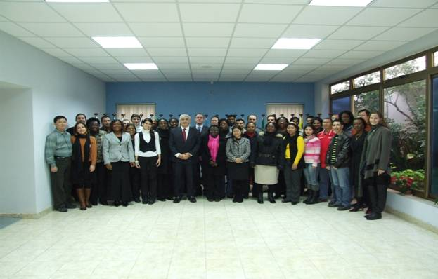

*Dr. Philippe Boisson, Prof. David Attard and the IMLI class of 2008/2009*

Dr. Boisson has been a visiting lecturer at IMLI since 1993 and is a member of the IMLI Governing Board. Being intensively involved in the maritime field, he has occupied high standing posts as Communication Director and Legal Adviser of the Bureau Veritas Marine Division. He is Vice-President of the French Maritime Law Association, Titulary Member of the CMI, and Arbitrator at the Chambre Arbitrale Maritime de Paris. Dr. Boisson has written many articles on the marine safety system and classification societies. He is the author of a major study entitled “Safety at Sea, Policies, Regulations and International Law” published by Bureau Veritas Publications in 1999. Dr. Boisson received an award by the French Marine Academy and the Albert Lilar Prize for his book.

In a short interview (reproduced below) he expressed his views with regard to his long experience as a visiting lecturer, the growth of the Institute and the factors that contributed to the latter.

**Doctor Boisson, you have been delivering the course on the Law of Maritime Safety to the IMLI students for 15 years now. How do you find the experience?**

I am excited, stressed though but always exited. And I am always impressed. At the beginning there were few students and (for two reasons) I was afraid whether they could understand my lectures. First, I am a French lawyer with a civil law background and I consider it difficult not only to deliver a lecture in English but also to make understand lawyers coming from common law countries. Second, I deal with technical matters which are complicated and difficult to be understood from people with no technical background.

However, in this respect the development of the Institute and the provision of such facilities as power point presentation, internet etc has had a major contribution in making these lectures attractive and comprehensive for everybody.

**What are the changes or developments you notice every year in the student body?**

What I notice is that every year students are more interactive during the lectures. They are not shy - a phenomena of the first year students – they do not hesitate to ask questions and they would like to have clear explanations in respect of what you are saying. This year’s class was impressive and I could not finish my lecture in time.

In my opinion this is very helpful and I certainly encourage such participation from the audience. Indeed, such reactive audience helps the lecturer to improve his way of teaching.

**What in your opinion are the developments in the Law of Maritime Safety?**

In respect of Maritime Safety more and more pressure will be put on the Flag States. Several mechanisms to monitor Flag State safety performance have been set up by IMO or are under construction by the European Union. One of the EU objectives in term of safety is to facilitate the implementation of international instruments by the EU member States.

It is also important to mention the IMO initiative in setting up the Voluntary Audit Scheme of the national maritime administration. More and more States have embraced the Voluntary Audit Scheme which is a great tool for the proper implementation of international maritime instruments. The problem nowadays is not the lack of regulations or the adoption of new ones. The international community is faced to correctly implement the existing regulations and to this end the contribution of the Voluntary Audit Scheme is considerable.

Furthermore, one has to mentions the new code for conducting investigations after a marine accident. This new code, made mandatory during the last meeting of the IMO Maritime Safety Committee will improve the knowledge of maritime administration in conducting investigations after the occurrence of an accident.

**IMLI celebrates this year its 20th anniversary; notably this year is marked by the largest and most diverse student body (37 students from 24 countries) and the remarkable increase of women participants. What in your opinion contributed to such a development?**

The academic reputation of IMLI is evident. IMLI is the place which brings together the best practitioners in maritime law. Every year world leading experts in different fields of maritime law visit IMLI and share they knowledge and experience with the participants. These visiting professors are extending considerably the reputation of the Institute.

On the other hand, as far as I am aware, IMLI is the only Institute in maritime law where both, the civil law and common law, systems coexist. Indeed, it is extremely rare to find this comparative system of teaching. Most educational institutions will be focused either on the civil law or, mainly, the common law approach. Therefore, in the light of the importance of exchanging views and opinion, this factor contributes to IMLI’s reputation.

In my opinion these are the two biggest advantages of IMLI which make the Institute the best maritime law educational centre in the world.

_________________________________

* *If you do not want to receive IMLI e-News in future, please return this message to the above address with request to DELETE in the subject field.*

*\*\* For further information please contact Ms. Elda Belja (Editor, IMLI e-News) at* [publications@imli.org](mailto:publications@imli.org)