Circulated in more than 100 States to personalities in the legal and maritime professions

IMLIe-News

The IMO International Maritime Law Institute Official Electronic Newsletter       (Vol.  6 , Issue No. 25) 06 February 2009

**FINANCIAL AND PERSONNEL MATTERS OF IMLI SUB-COMMITTEE**

This week the IMLI Sub-Committee on Financial and Personnel Matters met at the Headquarters of Lloyd’s Register in London.

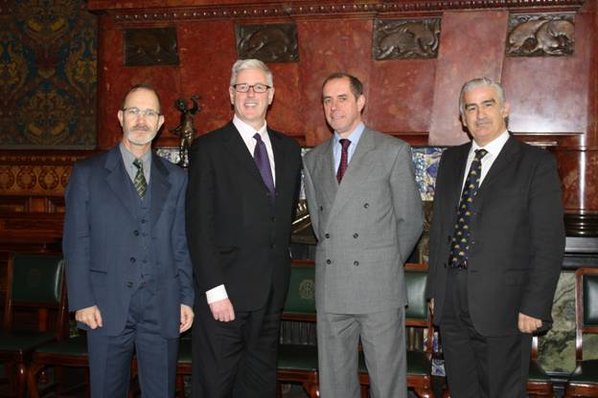

*Dr. Reto Dürler, Mr. Jim Harrison, Dr. Philippe Boisson and Prof. David Attard (Members of IMLI Sub-Committee)*

During this meeting, among other matters, the Sub-Committee discussed the financial documents to be submitted to the 23rd Session of the IMLI Governing Board scheduled to take place on 9 March 2009 at IMO Headquarters in London.

The Sub-Committee meeting was attended by Mr. Jim Harrison (Group Legal Director of Lloyd’s Register), Prof. David Attard (IMLI Director), Dr. Reto Dürler (Head of the Swiss Navigation Office) and Dr. Philippe Boisson (Communication Director and Legal Advisor of Bureau Veritas).

_________________________________

* *If you do not want to receive IMLI e-News in future, please return this message to the above address with request to DELETE in the subject field.*

*\*\* For further information please contact Ms. Elda Belja (Editor, IMLI e-News) at* [publications@imli.org](mailto:publications@imli.org)