Circulated in more than 100 States to personalities in the legal and maritime professions

IMLIe-News

The IMO International Maritime Law Institute Official Electronic Newsletter       (Vol.  6 , Issue No. 26)   13 February 2009

IOPC FUNDS’ FORMER DIRECTOR LECTURES AT IMLI

IMLI had the honour to host Mr. Måns Jacobsson, former Director of the International Oil Pollution Compensation Funds (IOPC Funds), as visiting lecturer at its 20th annual LL.M. Programme.

Mr. Jacobsson’s lectures form part of the Environmental Law component of IMLI’s LL.M. programme. During his lectures he gave a general presentation of the international liability and compensation regime for pollution damage caused by oil spills from tankers established by the Civil Liability and Fund Conventions which has been in operation for 30 years. He mentioned that the International Oil Pollution Compensation Funds (IOPC Funds) administering this regime have been involved in the settlement of compensation claims arising from some 140 oil spills worldwide and have paid compensation totaling US$ 900 million to governments and other public authorities for costs of clean up and to individuals and businesses for economic losses in the fisheries and tourism sectors. He emphasized that in most cases compensation had been paid within a relatively short period of time after the incident and without the victims having to go to court. He also made the point the IOPC Funds had in their decisions on the admissibility of compensation claims contributed to the development and unification of international law.

Mr. Jacobsson also gave a brief overview of the new regime created for compensation for pollution damage caused by spills of bunker oil by the International Convention on Civil Liability for Bunker Oil Pollution Damage, 2001 which had entered into force on 21 November 2008. Highlighting the differences between the new regime established by that Convention and the regime dealing with oil spills from tankers, he stressed the importance of the new regime in view of the experience in recent years that bunker spills can cause considerable pollution damage.

He finally addressed the International Convention on Liability and Compensation for Damage in Connection with the Carriage of Hazardous and Noxious Substances by Sea, 1996 which has not entered into force. He explained the reasons for its non entry into force and dealt with the steps that have been taken recently to develop a protocol to the Convention to overcome the obstacles to its entry into force, He expressed the view that this was probably the last possibility to establish a global regime dealing with liability and compensation issues in this important field. If this attempt were to fail there was in his view a significant risk of a regionalization of international law on this subject which he considered would be very unfortunate in view of the global character of the carriage of such substances by sea.

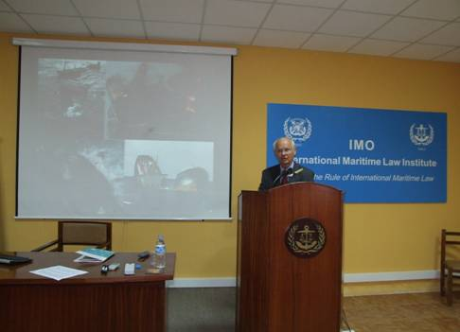

*Mr. Måns Jacobsson lecturing to IMLI class of 2008/2009*

Mr. Jacobsson was the Director of the International Oil Pollution Compensation Funds from 1985 to 2006. Previously he had performed a legal carrier in his home country Sweden, first as a judge, and later as legal advisor and eventually as Head of the Department for International Affairs of the Swedish Ministry of Justice where he was responsible for the preparation of legislation mainly in the fields of transport law, nuclear law and industrial property. He had represented Sweden in negotiations in a number of intergovernmental organisations, in particular in the IMO. He was appointed President of Division of the Stockholm Court of Appeal.

Mr. Jacobsson has published a book on patent law (together with two other co-authors). He has also published numerous articles in various fields of law.

He is a visiting professor at the World Maritime University in Malmö (Sweden) and the Maritime Universities in Dalian and Shanghai (Peoples Republic of China). He is also a lecturer at the University of Southampton, Swansea University and Nottingham University in the United Kingdom, Lund and Stockholm Universities in Sweden and the Summer Academy organised by the International Foundation for the Law of the Sea in Hamburg (Germany). He is member of the Steering Committee of the London Shipping Law Centre. Mr. Jacobsson is a Member of the Panel of the Singapore Maritime Arbitration Centre as well as Member of the International Maritime Conciliation and Mediation Panel. Furthermore, he is a member of the Executive Council of the Comité Maritime International (CMI).

In 2007 the University of Southampton conferred upon him the Honorary Degree of Doctor of Laws.

_________________________________

* *If you do not want to receive IMLI e-News in future, please return this message to the above address with request to DELETE in the subject field.*

*\*\* For further information please contact Ms. Elda Belja (Editor, IMLI e-News) at* [publications@imli.org](mailto:publications@imli.org)