Circulated in more than 100 States to personalities in the legal and maritime professions

IMLIe-News

The IMO International Maritime Law Institute Official Electronic Newsletter       (Vol.  6 , Issue No. 27) 16 February 2009

**FIFTH LITAV MARITIME SECURITY SEMINAR AT IMLI**

Major (Retd) Anthony Hall and Major (Retd) Martin Walker from LITAV (*Formazione* *Marittima Superiore*) delivered recently a two-day seminar on maritime security to the IMLI Class 2008/2009. The seminar has been delivered by LITAV to IMLI for the past five academic years and is one of the key subjects within IMLI’s course on Maritime Safety and Security. The aim of the seminar is to explain to its participants the legal implications and practical aspects of maritime security which together form a coherent whole for the protection of life and property at sea.

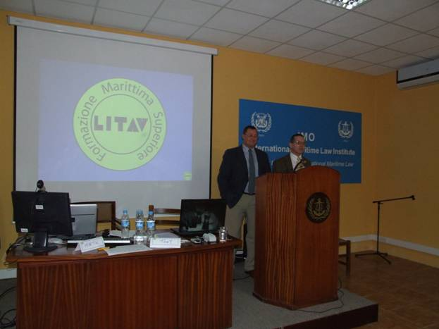

*Major Anthony Hall (right) and Major Martin Walker (left), of LITAV,*

*delivering lectures on the practical aspects of the ISPS Code to the Class of 2008/2009*

The course introduced the students to the procedures and processes necessary for the assessment of risks. It focused on the need to understand the threats that the maritime industry faces and the response given by States through the creation of international regulations and policies that cover maritime security as well as the national regulations that have been imposed. The importance of the ship security assessment, its relationship to the ship security plan, and the necessity for port security measures were also extensively explained and demonstrated during the seminar.

During the course on the Company and Ship Security Officer Training IMLI students were exposed to theoretical situations and practical exercises wherein they could apply the knowledge imparted to them during the seminar.

Major Anthony Hall was previously with the Royal Air Force and later transferred to the Intelligence Corps of the British Army where he served for 24 years. During his career, his primary areas of expertise were counter-intelligence, protective security, intelligence analysis and exploitation, and counter-terrorism.

Major Martin Walker worked with the Intelligence Corps of the British Army for 28 years. During his last five years in the service he served as Officer Commanding and Senior Instructor Surveillance Branch Joint Service Intelligence Organization where he was responsible for all aspects of management, development and implementation of specialist covert surveillance training, including the requirement to train Intelligence Corps and authorized personnel from other agencies.

_________________________________

* *If you do not want to receive IMLI e-News in future, please return this message to the above address with request to DELETE in the subject field.*

*\*\* For further information please contact Ms. Elda Belja (Editor, IMLI e-News) at* [publications@imli.org](mailto:publications@imli.org) C