Circulated in more than 100 States to personalities in the legal and maritime professions

IMLIe-News

The IMO International Maritime Law Institute Official Electronic Newsletter       (Vol.  6 , Issue No. 28)   19 February 2009

**CHINESE AMBASSADOR TO MALTA VISITS IMLI**

Members of IMLI Class 2008/2009 had the pleasure of meeting His Excellency, Ambassador Chai Xi **(**China’s Ambassador to Malta**)** at a reception tendered in his honour.

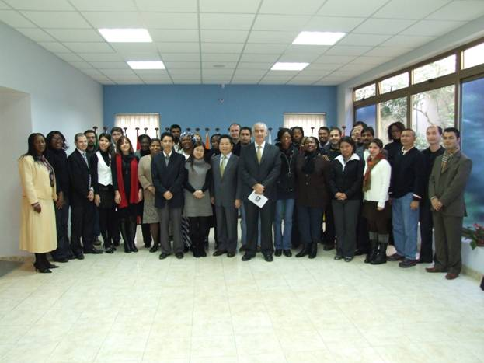

*Ambassador Chai Xi with Professor David Attard and the IMLI class 2008/2009*

The Ambassador was welcomed by Professor David Attard who expressed his great pleasure at His Excellency’s visit and stated that the Institute has always enjoyed a very fruitful relationship with the Embassy of China in Malta. He recognized that China, as a nation with a significant merchant marine fleet, is fast becoming a leader in global maritime trade. Professor Attard recalled that the presence of the convoy fleet to the waters off the Somali coast, East Africa is a historical moment and reflects the strong role China is playing in the international fora. In this respect, China’s interest in training its legal practitioners in the field of maritime law is a natural consequence of this growth. Professor Attard pointed out that IMLI has several Chinese graduates.

In his response, Ambassador Chai Xi thanked Professor Attard for his longstanding friendship towards China and his kind invitation to visit IMLI, which he considered to be an excellent opportunity to meet and exchange views with all the participants. Further, Ambassador Chai Xi stated that *‘IMLI has trained numerous legal lawyers with specialization in maritime and shipping law and is recognized as the foremost educational institute in this field. For this, I congratulate the students for having the opportunity to undergo training at IMLI, as I believe such an experience will not only benefit your personal knowledge enrichment as well as your career advancement, but more importantly and in a broader context, it will enable you to better serve the need of your country with your specialization and expertise obtained in maritime law.’*

Seizing the opportunity His Excellency explained to the students that “*China has taken on a new look. China's diplomacy has made bold headway, serving domestic development and contributing to world peace and common development. China now enjoys enhanced international status and increasing world influence and its friendly and cooperative relationships with other countries have been further consolidated and strengthened.”*

_________________________________

* *If you do not want to receive IMLI e-News in future, please return this message to the above address with request to DELETE in the subject field.*

*\*\* For further information please contact Ms. Elda Belja (Editor, IMLI e-News) at* [publications@imli.org](mailto:publications@imli.org)