Circulated in more than 100 States to personalities in the legal and maritime professions

IMLIe-News

The IMO International Maritime Law Institute Official Electronic Newsletter       (Vol.  6 , Issue No. 29)   20 February 2009

**AUSTRALIAN PROFESSOR LECTURES ON CARGO INSURANCE**

IMLI had the honour to host Professor Ping-fat Sze who lectured on Cargo Insurance to the students of class 2008/2009. Professor Sze is a chartered arbitrator, an highly respected legal practitioner in Australia and an Adjunct Professor of Asia International Open University in Macao. He was formerly a professor of law in the University of Macao and a visiting fellow of Clare Hall in the University of Cambridge.

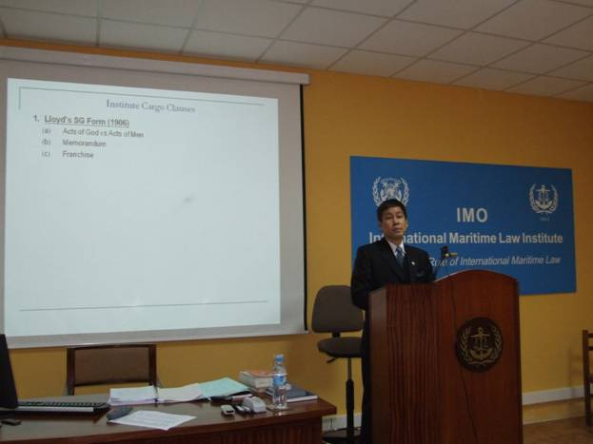

*Professor Sze during his lecture to the IMLI class 2008/2009*

His lectures focused on the Institute Cargo Clauses, the Institute War Clauses and the Institute Strikes Clauses within the general context of the UK Marine Insurance Act 1906. Professor Sze provided the students also with a critical analysis of the problems identified with the application of the MIA, as for example*, ‘that the ‘prudent insurer’ test – together with the generous construction accorded to the ‘materiality’ requirement – works unfairly against the assured. So does the remedy of avoidance available even where the non-disclosure was innocent,or has not influenced the insurer, or is not causally linked to the loss at all.’*

Professor Sze expressed his great pleasure lecturing again to IMLI students on marine cargo insurance which has been one of his favourite subjects. He recalled that ‘*despite the fact that very few students have read cargo insurance before, it is most encouraging seeing that IMLI students respond so ably and intelligently to questions raised throughout the lectures. They have no difficulty at all synthesizing legal concepts and identifying problems over the compatibility of these standard terms with existing liability regimes for sea-carriers.*’

In his view “*IMLI is a leader in the provision of advanced education and training for specialists in maritime law and practice. Its students come from different parts of the world and it is a pleasure to hear that IMLI graduates have proved to be so successful in their career advancement and contribution to their countries in the application of international* *maritime law*.”

_________________________________

* *If you do not want to receive IMLI e-News in future, please return this message to the above address with request to DELETE in the subject field.*

*\*\* For further information please contact Ms. Elda Belja (Editor, IMLI e-News) at* [publications@imli.org](mailto:publications@imli.org)