Circulated in more than 100 States to personalities in the legal and maritime professions

IMLIe-News

The IMO International Maritime Law Institute Official Electronic Newsletter          (Vol. 6, Issue No.3) 19 September 2008

**PRESIDENT OF THE 45th UN GENERAL ASSEMBLY LECTURES AT IMLI**

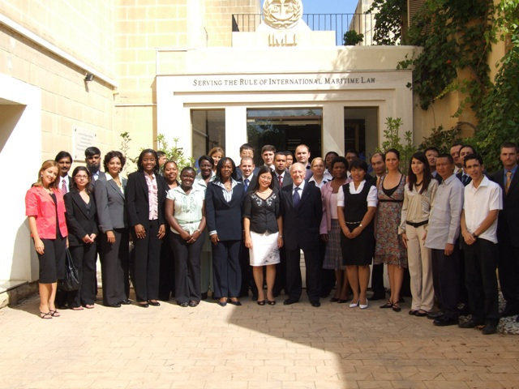

Prof. Guido de Marco, President of the 45th UN General Assembly, with the IMLI Class 2008-2009

Professor Guido DeMarco, President Emeritus of Malta and President of the 45th Session of the United Nations General Assembly (1990-1991), commenced his course of lectures on the United Nations on the 18th September 2008, within the framework of the Course on International Institutions. The lectures will give the students an over-view of the role of the United Nations. Professor DeMarco, through an analysis of the structure of the United Nations will examine the importance and functioning of the United Nations’ principal organs. The course also includes an analysis of the salient provisions of the UN Charter. The lectures will be delivered from an academic point of view enriched by Professor DeMarco's vast experience in diplomacy.

Professor DeMarco was introduced by the Director, Professor David Attard, who spoke of his immense experience in diplomacy and his contribution to bring the United Nations closer to the individual. Professor DeMarco thanked the Director and said that it is his pleasure to be lecturing at the Institute again. He recalled his discussions with the Director which led to important proposals on the future of the UN Trusteeship Council.

*___________________________________*

* *If you do not want to receive IMLI e-News in future, please return this message to the above address with request to DELETE in the subject field.*

*\*\* For further information please contact Ms. Elda Belja (Editor, IMLI e-News) at* [publications@imli.org](mailto:publications@imli.org)