Circulated in more than 100 States to personalities in the legal and maritime professions

IMLIe-News

The IMO International Maritime Law Institute Official Electronic Newsletter       (Vol.  6 , Issue No. 30)  27 February 2009

**PUBLIC INTERNATIONAL LAW PROFESSOR OF UNIVERSITY OF LONDON LECTURES AT IMLI**

IMLI had the honour to host recently Professor Malgosia Fitzmaurice who delivered two lectures to the students of IMLI class 2008/2009.

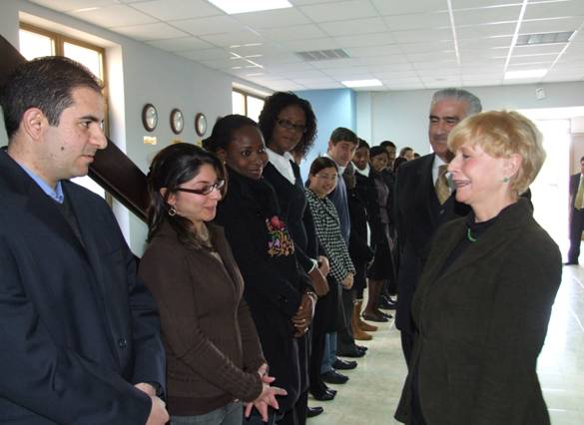

*Professor Malgosia Fitzmaurice meeting the students of class 2008/2009*

Professor Fitzmaurice holds a chair of public international law at the Department of Law, Queen Mary, University of London. She specializes in international environmental law, indigenous peoples, water law and the law of treaties. Her lectures at IMLI dealt with the “Protection of the Marine Environment on the basis of the Global Conventions (MARPOL 73/78; London Convention 1972 and the 1996 Protocol; and the 1982 United Nations Law of the Sea Convention)” and “The Protection of Marine Living Resources with specific reference to the protection of whales”.

Professor Fitzmaurice has lectured widely in the United Kingdom and abroad at various universities, such as Utrecht and Brussels, Oslo, University of Lapland and at the World Bank in 2001. She has taught extensively in various law schools, most recently at the Berkeley University School of Law of the United States. In July 2001, she was invited to deliver lectures on “International Protection of the Environment” at the Hague Academy of International Law.

Professor Fitzmaurice has many publications on all these subjects. Until 2001, she was a member of the Board of Editors and one of the Editors of the Netherlands Yearbook of International Law. She is the Editor in Chief of the International Community Law Review and a Co-Rapporteur of the International Law Association Committee on Non-State Actors.

Professor Fitzmaurice has also participated in many international conferences in which she was a keynote speaker.

_________________________________

* *If you do not want to receive IMLI e-News in future, please return this message to the above address with request to DELETE in the subject field.*

*\*\* For further information please contact Ms. Elda Belja (Editor, IMLI e-News) at* [publications@imli.org](mailto:publications@imli.org)