Circulated in more than 100 States to personalities in the legal and maritime professions

IMLIe-News

The IMO International Maritime Law Institute Official Electronic Newsletter       (Vol.  6, Issue No. 32)  06 March 2009

**ITALIAN NAVY EXPERT LECTURES AT IMLI**

Rear Admiral Fabio Caffio (Expert of International Maritime Law, Italian Navy) visited the Institute and delivered a lecture on “The legal regime of Mediterranean and Black Sea: A historical perspective”.

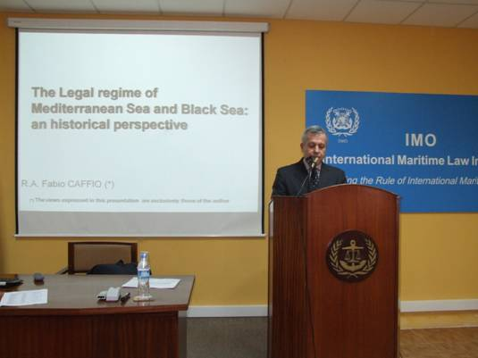

*Rear Admiral Caffio during his lecture to the IMLI class 2008/2009*

His lecture focused on the history of the legal maritime regime of the Mediterranean that shows the struggles for and against the concept of free sea since the time of Ancient Romans who first established some divisions of Maritime Mediterranean Spaces by treaties with Carthage and Tarentum.

Admiral Caffio analyzed also the role of *Paladin Mare Liberum* assumed by the United States during the cold war undertaking actions in the Mediterranean and Black Sea to protest specific maritime claims considered inconsistent with international law.

He concluded his lecture by stating that “considering the lesson *of History, Mare Liberum* rule, as applied in Mediterranean Sea as in other semi-enclosed sea, is not a theoretical concept but an essential and vital principle”.

Before joining the Italian Navy, Admiral Caffio studied Law at the University of Rome where he worked for two years as assistant Professor at the Department of Criminal Law. Later he attended compulsory military service as an officer of the Coast Guard and, in 1976 he became Lieutenant of the “Corpo di Commissariato” of the Italian Navy. Presently Admiral Caffio works in the Italian Navy General Staff, as Vice Head of UGCRA.

As an expert of maritime law he was representative of the IT MOD in several international meetings concerning maritime delimitations, negotiations of maritime agreements, PSI and maritime terrorism. He participated also at the meetings of the International Group of experts convened by the IIHL in order to draft the “San Remo Manual on International Law applicable to armed conflicts at sea” (1993 and 1994). He was a member of the Italian delegation at the Diplomatic Conference for the Statute of the International criminal Court (1998).

Admiral Caffio is member of the “Societe Internationale de Droit Militaire et de Droit de la Guerre”.

_________________________________

* *If you do not want to receive IMLI e-News in future, please return this message to the above address with request to DELETE in the subject field.*

*\*\* For further information please contact Ms. Elda Belja (Editor, IMLI e-News) at* [publications@imli.org](mailto:publications@imli.org)