Circulated in more than 100 States to personalities in the legal and maritime professions

IMLIe-News

The IMO International Maritime Law Institute Official Electronic Newsletter       (Vol.  6, Issue No. 33)  11 March 2009

**INTERNATIONAL MULTIMODAL TRANSPORT ASSOCIATION PRESIDENT LECTURES AT IMLI**

Dr. Mahin Faghfouri, President of the International Multimodal Transport Association recently visited IMLI and delivered a series of lectures on multimodal transport, the impact of the UNCITRAL Draft Convention on Carriage of Goods (wholly or partly) by Sea on multimodal transport and the 1999 International Convention on Arrest of Ships to the students of the class 2008/2009.

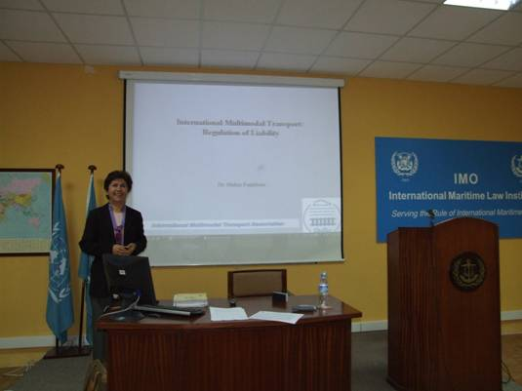

In her lectures on multimodal transport Dr. Faghfouri not only provided the students with a historical background on the development of this mode of transport, but explained its significance and focused on recent developments on the field. In this respect, she discussed, *inter alia*, the current international liability framework for unimodal transport and the efforts made by the international community to achieve an uniform international regime for multimodal transport.

In her lecture on the 1999 Arrest of Ships Convention, Dr. Faghfouri provided an overview of this convention emphasizing the new provisions which represent an improvement of its predecessor.

Dr. Faghfouri has a Ph.D. degree from the University of Wales and a Master’s degree in Maritime Law from the London University. She studied law at the Law Faculty of the University of Tehran. Dr. Faghfouri has a long career in UN Conference on Trade and Development where she had been a Chief of the Maritime Legislation / Legal Section of the Division for Services Infrastructure for Development and Trade Efficiency from 1984 until 2005. At the said position she was responsible for the work within UNCTAD on maritime law and multimodal transport including International Convention on Arrest of Ships 1999, International Convention on Maritime Liens and Mortgages 19993, UNCTAD Minimum Standards for Shipping Agents, UNCTAD’s work on bills of lading, charterparties, general average, legal aspects of electronic commerce and maritime and container security. Since 2005 until the present day she has held a position of President of the International Multimodal Transport Association.

_________________________________

* *If you do not want to receive IMLI e-News in future, please return this message to the above address with request to DELETE in the subject field.*

*\*\* For further information please contact Ms. Elda Belja (Editor, IMLI e-News) at* [publications@imli.org](mailto:publications@imli.org)