Circulated in more than 100 States to personalities in the legal and maritime professions

IMLIe-News

The IMO International Maritime Law Institute Official Electronic Newsletter       (Vol.  6 , Issue No. 34)  13 March 2008

**INTERNATIONAL SALVAGE UNION LEGAL ADVISER LECTURES AT IMLI**

Mr. Archie Bishop, Legal Adviser to the International Salvage Union visited recently IMLI and delivered his traditional course on the Law of Maritime Salvage to the students of class 2008/2009.

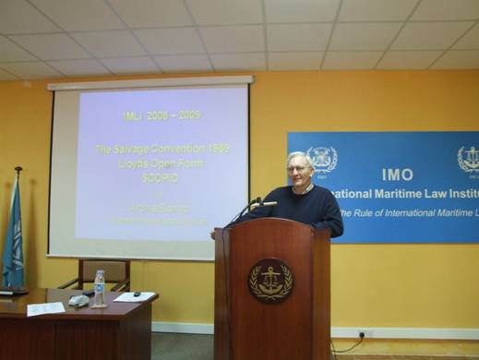

*Mr. Archie Bishop during his lecture to the IMLI class 2008/2009*

In his lectures Mr. Bishop discussed the history and development of salvage law through the centuries, followed by a close examination of the essential articles of the Salvage Convention 1989 with particular emphasis on the assessment of salvage award and its special compensation provisions. He then explained to the students the history of Lloyd’s Open Form 2000 (LOF 2000), its administration and the effect of its clauses, particularly the SCOPIC clause which has largely replaced the Special Compensation provisions of the Convention. He concluded with a detailed discussion of the extent to which the environment plays a part in modern day salvage and possible solutions as to how the protection of the environment could be better rewarded.

Mr. Bishop is a longstanding friend and supporter of the Institute and has been indeed a visiting fellow and external examiner at IMLI for many years. When asked about the students of this year he stated that *“Throughout, I found the students to be an attentive audience. They had quick minds which displayed a deeper knowledge of the subject than I had expected and questioned principles critically to better understand the subject. In short, they were a sharp team before whom it was a pleasure to lecture and share thoughts and experiences. I enjoyed their reactive company”.*

Mr. Bishop is considered one of the most appreciated specialists in this field of maritime law. He is a Solicitor both in England and Hong Kong, an Examiner in Admiralty and until recently was the Senior Partner of Holman Fenwick & Willan with whom he is now a Consultant. He is the Legal Adviser to the International Salvage Union, worked with International Maritime Organisation's Legal Committee in preparing the Salvage Convention, 1989, is a member of the drafting committee of LOF and played a leading role in the development of the SCOPIC Clause. He sits on the Salvage Committee of the British Maritime Law Association and the Salvage Liaison Group and is the Chairman of the Steering Committee of the London Shipping Law Centre. He is a CEDR Accredited Mediator and a visiting lecturer to the University College London. He is also a frequent contributor and speaker at international conferences. Prior to his legal career he was trained aboard HMS Worcester where he served 7 years as a deck officer with the P&O Line.

_________________________________

* *If you do not want to receive IMLI e-News in future, please return this message to the above address with request to DELETE in the subject field.*

*\*\* For further information please contact Ms. Elda Belja (Editor, IMLI e-News) at* [publications@imli.org](mailto:publications@imli.org)