Circulated in more than 100 States to personalities in the legal and maritime professions

IMLIe-News

The IMO International Maritime Law Institute Official Electronic Newsletter       (Vol.  6 , Issue No. 36) 20 March 2009

**EU COMMISSIONER ADRESSES IMLI’S 14TH EU MARITIME LAW COURSE**

H.E. Dr. Joe Borg, EU Commissioner for Fisheries and Maritime Affairs officially closed the 14th IMLI EU Maritime Law Course today, 20 March 2009.

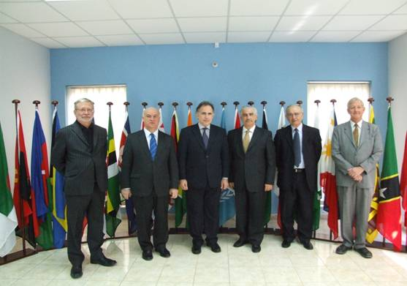

*Sir R. Coleman, Commissioner J. Borg, Ambassador A. Rallis, Professor D. Attard, Mr. P. Mairangas and Mr. B. Nielsen*

*“I greatly appreciate the fact that I am invited on a yearly basis to address the students who take part to this course which leads to a specialized qualification in maritime law. Without doubts, the fact that I am given the occasion to outline the progress that we have been registering over these last four years regarding the development of an integrated maritime policy has also served the purpose to engage in very fruitful discussion on the subject and to launch new ideas in this regard.”* Commissioner Joe Borg

IMLI’s intensive EU Maritime Law course offered the participants an overview of the EU Maritime Law, including the EU Maritime Transport Policies on safety and criminal sanctions in the protection of marine environment, the external dimensions of EU maritime law on the maritime transport policy, EU law on marine pollution, etc.

IMLI’s Director, Professor David Attard opened the ceremony by delivering a welcoming address. Professor Attard recalled that IMLI was the first international academic institution which included EU maritime law as part of its studies. He explained that EU maritime law is relevant to lawyers from all over the world. Whereas EU Member States’ lawyers will be directly dealing with EU law, lawyers coming from Non-Member States benefit as well from EU Maritime Law training as this would enable them to deal with many circumstances, including instances where a ship registered in their country faces problems in an EU Member State. He highlighted the active role Commissioner Borg has contributed in the development of the integrated maritime policy within the EU Community.

Commissioner Borg then delivered to the audience his address entitled “Making Headway on the Integrated Maritime Policy”.

In his words “The Integrated Maritime Policy brings with it a new geo-political vision for Europe’s vast maritime dimension.” This new vision allows dealing with climate change, the unfolding global economic crisis, the building of a framework with common objectives of all EU Policies with a maritime dimension and the enriching of knowledge and capacity to act.

An integrated EU Maritime Policy reflects the Commission’s strategic objectives for 2005-2009 and “the particular need for an all-embracing maritime policy aimed at developing a thriving maritime economy, in an environmentally sustainable manner. Such a policy should be supported by excellence in marine scientific research, technology and innovation”. Commissioner Borg recalled that the project is already four years old and “it is not only one of the singular most important legacies that the Barroso Commission will leave to its successors at the end of the year, but it is also one of the most far-reaching”.

He emphasized that maximizing the sustainable use of the oceans and seas, building a knowledge and innovation base, delivering the highest quality of life in coastal regions, promoting Europe’s leadership in international affairs and raising visibility for Maritime Europe are the five main actions that have been identified in the Blue Paper to take the Integrated Maritime Policy forward. These objectives make certain that due attention is given to maritime interests at all levels of policy, from coastal regions of Europe to fora with global coverage and push for the importance of recognizing maritime issues within civil society at large.

To achieve these aims the maritime policy agenda has included *inter alia* the Marine Strategy Framework Directive (2008), Council Regulation on the protection of marine scientific ecosystems in the high seas from the adverse impacts of bottom fishing gears (July 2008), the forthcoming Strategy for Adaption to Climate Change, the Maritime Research Strategy (September 2008), Council Regulation to prevent IUU Fisheries (September 2008), a Strategy for ship dismantling (November 2008), Maritime Transport Space without Barriers – Maritime Transport Strategy 2009-2018 (January 2009), as the most important policy initiatives. The Commissioner recalled the pivotal role Member States play in achieving the ambitious maritime policy goals.

Concluding, Commissioner Borg mentioned two forthcoming milestones for the Integrated Maritime Policy. First, on 20 May 2008 the Presidents of EU institutions signed a declaration signaling the celebration of a European Maritime Day each year. From 19 to 20 May 2009 a conference will be organized in Rome with the participation of stakeholders throughout Europe. Second, the Commission will deliver this autumn a progress report on maritime affairs and activities and will suggest the way ahead for an Integrated Maritime Policy.

_________________________________

* *If you do not want to receive IMLI e-News in future, please return this message to the above address with request to DELETE in the subject field.*

*\*\* For further information please contact Ms. Elda Belja (Editor, IMLI e-News) at* [publications@imli.org](mailto:publications@imli.org)