Circulated in more than 100 States to personalities in the legal and maritime professions

IMLI e-News

The IMO International Maritime Law Institute Official Electronic Newsletter       (Vol.  6 , Issue No. 38)   24  March 2009

# SECRETARY GENERAL OF THE HAGUE ACADEMY OF INTERNATIONAL LAW LECTURES AT IMLI

IMLI had the honour to host Professor Yves Daudet, Emeritus Professor of Public International Law at the University Panthéon-Sorbonne (Paris I) and Secretary General of The Hague Academy of International Law as visiting professor at its 20th annual LL.M. Programme.

In his lectures Professor Daudet dealt with “The Process of Elaboration of International Law with Special Emphasis on the Law of the Sea” and “Current Aspects of the Security Council”.

When discussing the process of elaboration of international law Professor Daudet explained that *“a distinction has to be drawn between codification and elaboration. The aim of codification is to establish a regime of legal rules trying to have a mere coherent and well-balanced codification, taking into account all the necessary changes but on the basis of existing law. On the other hand elaboration occurs in the cases of the development of new rules and concepts. However, this distinction is rarely mentioned as codification is one way amongst others to elaborate international law. The law of the sea is the best example of this kind of mixture between codification of customary international rules on one hand and the progressive development of new rules on the other.”*

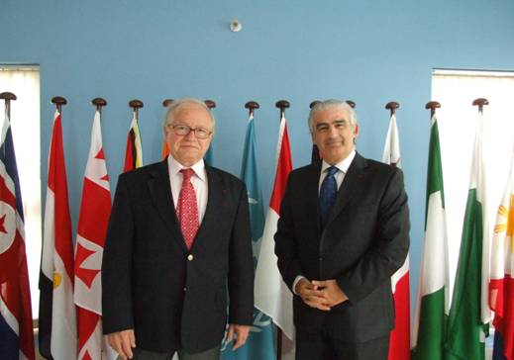

*Professor Yves Daudet and Professor David J. Attard*

# In his lecture on the “Current Aspects of the Security Council” Professor Daudet mainly focused on the functioning of the Security Council, how it is formed and its importance in today's international society.

# Professor Daudet has a brilliant academic career which dates back to 1964. He has been Professor of law in different Universities of France as University of Bordeaux, University of Aix-Marseille and abroad e.g. Faculty of Law Rabat, University of Abidjan (Ivory Coast). He is the Founder and Head of the School of Law of the University of Mauritius.

# From 1995 to 2008 he was Professor at the University Panthéon-Sorbonne Paris I. Since 2008 he is Emeritus Professor of Public International Law at the University Panthéon-Sorbonne Paris I. Professor Daudet is presently the Secretary General of The Hague Academy of International Law.

He has taught as a visiting lecturer in more than 50 Countries including Algeria, Argentina, Germany, Greece, Kosovo, Kuwait, Benin, Cambodia, Canada, Chile, Martinique Island, Lebanon, Philippines, Spain, Sweden, Switzerland, Syria, United Kingdom, United States and Viet Nam.

# Professor Daudet is Member of Société Française pour le Droit International, Member of the International Law Association and has been honoured with the title of Chevalier de la Légion D’honneur.

# He was a member of the French Delegation at the Experts Group and at the United Nations Conference on the International Transfer of Technology.

Professor Daudet is Member of the Board of Editors of Annuaire Français de Droit International and the author of numerous books and publications.

# 

_________________________________

* *If you do not want to receive IMLI e-News in future, please return this message to the above address with request to DELETE in the subject field.*

*\*\* For further information please contact Ms. Elda Belja (Editor, IMLI e-News) at* [publications@imli.org](mailto:publications@imli.org)