Circulated in more than 100 States to personalities in the legal and maritime professions

IMLIe-News

The IMO International Maritime Law Institute Official Electronic Newsletter       (Vol.  6 , Issue No. 39)    27 March 2009

**IMLI GOVERNING BOARD MEMBER APPOINTED ON THE 21-MEMBER NAVIGATION SAFETY ADVISORY COUNCIL**

Professor Frank L. Wiswall, Jr., Vice-President Honoris Causa of the Comité Maritime International (CMI) and Member of the IMLI Governing Board and IMLI Academic Committee has been appointed by the U.S. Secretary of Homeland Security to a 3-year term on the 21-member Navigation Safety Advisory Council (NAVSAC).

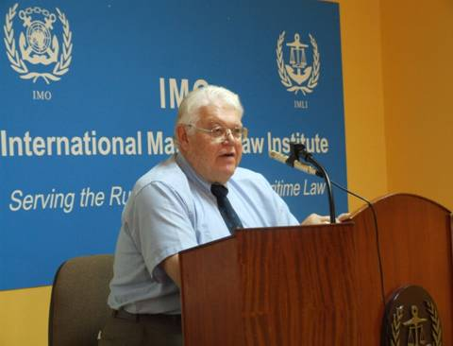

*Professor Frank L. Wiswall Jr. delivering the course on “Marine Collision” to the IMLI class 2008/2009*

NAVSAC was established by the U.S. Congress as a deliberative body to advise the Secretary, via the Commandant of the Coast Guard, on matters relating to the prevention of collisions, rammings and groundings, including, but not limited to: Inland Rules of the Road, International Rules of the Road, navigation regulations and equipment, routing measures, marine information, diving safety, and aids to navigation systems.

________________________________________________________________________

 * If you do not want to receive IMLI e-News in future, please return this message to the above address with request to DELETE in the subject field.

** For further information please contact Ms. Elda Belja (Editor, IMLI e-News) at [publications@imli.org](mailto:publications@imli.org)