Circulated in more than 100 States to personalities in the legal and maritime professions

IMLI e-News

The IMO International Maritime Law Institute Official Electronic Newsletter       (Vol.  5 , Issue No. 41)   03 April 2009

1. **SECRETARY GENERAL OF THE PARLIAMENTARY ASSEMBLY OF THE MEDITERRANEAN VISITS IMLI**
2. Dr. Sergio Piazzi (Secretary General of the Parliamentary Assembly of the Mediterranean) paid an official visit to the Institute on the occasion of the lecture delivered by H.E. Ambassador Alexandros Rallis (Greek Ambassador to Malta) on the “Delimitation of Maritime Boundaries Negotiations”.

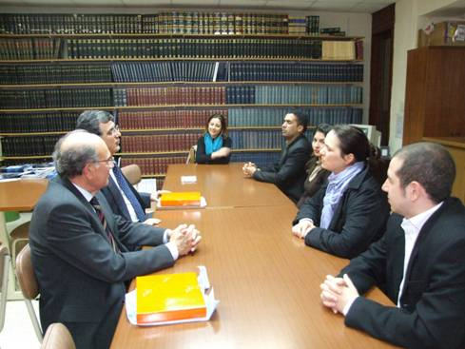

*Dr. Sergio Piazzi, Ambassador Alfred Zarb and students coming from*

*the Mediterranean Region*

1. After the lecture, Dr. Piazzi met IMLI students coming from countries of the Mediterranean Region. During the meeting, Dr. Piazzi who was accompanied by Ambassador Alfred Zarb (Adviser, Ministry of Foreign Affairs of Malta), explained to the students that the Mediterranean Parliamentary Assembly was established on the will to "...address issues of common concern to foster and enhance further confidence between Mediterranean States so as to ensure regional security and stability, and to promote peace. Its primary mission is therefore to assert the centrality of the Mediterranean area and reaffirm the key role of the Organization`s Members in addressing their common interests and shared concerns through a forum specifically created for that purpose. "
2. He recalled that all the Mediterranean countries, irrespective of their size and location, are represented in the Assembly on equal footing with the same voting power. In this respect, he explained that although the resolutions adopted by the Assembly were not binding upon the States, they are of a consultative nature and are taken into consideration when States enact different national laws.

Dr. Piazzi highlighted that the detailed work of the Assembly is carried out by the three Standing Committees, which issue opinions and recommendations. The Standing Committees are central to the functioning and deliberations of the Assembly and they focus their attention on the following strategic areas: **First Standing Committee**: Political and Security – related Cooperation, Regional Stability; **Second Standing Committee**: Economic, Social and Environmental Cooperation – Co-development and partnership; **Third Standing Committee**: Dialogue among Civilizations and Human Rights.

Dr. Piazzi is an Alumnus of Nunziatella military school of Napoli. He holds an Honoris Degree Doctorate in Political Sciences, University of Naples, and attended the Diplomatic School in Rome. He also holds a Masters in Economics and Foreign Trade, MFT, Rome and a Crisis Management Certificate of the University of Wisconsin, USA.

In his career, Dr. Piazzi served inter alia, as UN Representative in Romania in 1989/1990, UNDRO delegate in Persian Gulf Region in 1990 as special assistant to Mr. Martii Ahtisaari; Policy Adviser to the Special Representative of the Secretary-General in Iraq in 1991/1992; as UN Representative to Operation Turquoise in Rwanda in 1994 etc. He developed the UN NATO policy framework in relation to cooperation in civil emergency management in the context of Partnership for Peace. In 200o, Dr. Piazzi organized the Fribourg Forum, the UN Ministerial Conference on European Cooperation and Coordination in Crisis Management. In 2001, he finalized the UN-Greek-Turkish trilateral cooperation protocol. In 2004, he negotiated the UN/EC agreement on cooperation in emergency operations. In 2005, he was offered the position of NATO Deputy Assistant Secretary General for Operations.

1. _________________________________
2. * *If you do not want to receive IMLI e-News in future, please return this message to the above address with request to DELETE in the subject field.*
3. *\*\* For further information please contact Ms. Elda Belja (Editor, IMLI e-News) at* [publications@imli.org](mailto:publications@imli.org)