Circulated in more than 100 States to personalities in the legal and maritime professions

IMLI e-News

The IMO International Maritime Law Institute Official Electronic Newsletter       (Vol.  6 , Issue No. 42)   09 April 2009

1. **SANNIO UNIVERSITY (BENNEVENTO, ITALY) RESEARCHER DELIVERS A LECTURE AT IMLI**
2. Dr. Roberto Virzo (Researcher of Sannio University (Bennevento, Italy**)**) recently visited IMLI and delivered a lecture to the IMLI class 2008/2009 on “Dispute Settlement in UNCLOS and other Law of the Sea treaties”.

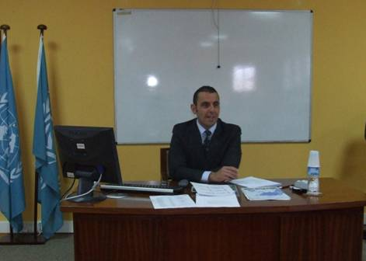

*Dr. Roberto Virzo during his lecture*

1. In his lecture Dr. Virzo mainly focused on Articles 281 and 282 of UNCLOS and on the application mutatis mutandis of Part XV of UNCLOS as provided by Part VII of the New York Straddling Stocks Agreement of 1995 and by other recent multilateral Law of the Sea Agreements.

Dr. Virzo has a degree in Political Sciences from the LUISS Guido Carli University (with magna cum laude), and a Doctorate in International Law from the University of Bari, Law Faculty.

Since 2008 he has been a Researcher of International Law at the University of Sannio of Benevento. He is currently a lecturer at the International Organisations at the University of Sannio, Benevento and the European Union Law at the Naval Academy of Livorno.

Dr. Virzo is the Editorial Assistant of the journal “*Studi sull’integrazione europea”*. He was asked by Prof. Rüdiger Wolfrum to contribute to the Max Planck Encyclopaedia of Public International Law on the following entries: “Central American Court of Justice”; “Lighthouses and Lightships”; “International Association of Marine Aids to Navigation and Lighthouse Authorities”; “Marine Living Resources, International Protection”.

Dr. Virzo is the author of numerous publications in Italian and English.

_________________________________

1. * *If you do not want to receive IMLI e-News in future, please return this message to the above address with request to DELETE in the subject field.*
2. *\*\* For further information please contact Ms. Elda Belja (Editor, IMLI e-News) at* [publications@imli.org](mailto:publications@imli.org)