Circulated in more than 100 States to personalities in the legal and maritime professions

IMLIe-News

The IMO International Maritime Law Institute Official Electronic Newsletter       (Vol.  6 , Issue No. 44)   30 April  2009

**UNITED NATIONS SECRETARY-GENERAL VISITS IMLI**

H.E. Mr. Ban Ki-moon, (United Nations Secretary-General) visited Malta on 21 and 22 April, the first visit by a UN Secretary General in 21 years. On the said occasion His Excellency paid a visit to the Institute on 21 April. During the visit to the Institute he also inaugurated a climate change monument at the University.

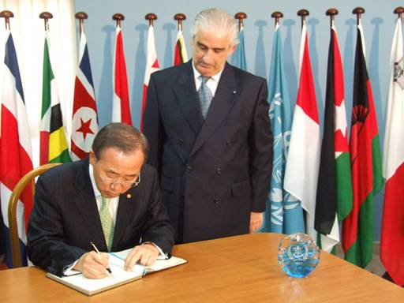

*H.E. Mr. Ban Ki-moon signing the IMLI Guestbook*

In his address to the University of Malta Faculty, students and guests, His Excellency made particular reference to IMLI by stating that “*The Institute’s mission is timely and important. The training and research that takes place here are helping to make shipping safe and efficient. You are helping to prevent marine pollution and you are building quietly immediate human capacity, so that developing countries can fulfill the obligations under the maritime law, in particular the Law of the Sea convention. I am pleased to note that the Institute was established with the backing of the International Maritime Organization, a member of the United Nations family*.”

_________________________________

* *If you do not want to receive IMLI e-News in future, please return this message to the above address with request to DELETE in the subject field.*

*\*\* For further information please contact Ms. Elda Belja (Editor, IMLI e-News) at* [publications@imli.org](mailto:publications@imli.org)