Circulated in more than 100 States to personalities in the legal and maritime professions

IMLI e-News

The IMO International Maritime Law Institute Official Electronic Newsletter       (Vol.  6 , Issue No. 45)   1 May 2009

1. **THE SECRETARY-GENERAL OF THE INTERNATIONAL MARITIME ORGANIZATION TO RECEIVE HONORARY DOCTORATE FROM**
2. **THE UNIVERSITY OF MALTA**
3. The Secretary-General of IMO, H.E. Mr. Efthimios E. Mitropoulos will receive the Degree of Doctor of Laws Honoris Causa from the University of Malta. The ceremony will be held at the Jesuits Church, Merchant Street, Valletta on 2 May 2009 at 10:00 a.m.
4. 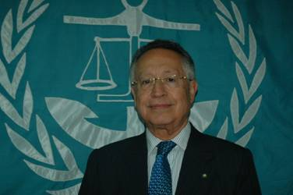
5. *H.E. Mr. Efthimios E. Mitropoulos*
6. *Secretary - General, IMO*
7. The honorary title is being conferred upon the Secretary-General in recognition of his significant contribution to serve the world maritime community with total commitment to ensure safe, secure and efficient shipping on clean oceans.
8. Mr. Efthimios E. Mitropoulos was elected Secretary-General of IMO by the ninetieth session of the IMO Council on 18 June 2003 for an initial four-year period beginning 1 January 2004. On 9 November 2006 at the ninety-seventh session of the IMO Council, Mr. Mitropoulos’ mandate was renewed for a further four-year period until 31 December 2011.
9. _________________________________
10. * *If you do not want to receive IMLI e-News in future, please return this message to the above address with request to DELETE in the subject field.*
11. *\*\* For further information please contact Ms. Elda Belja (Editor, IMLI e-News) at* [publications@imli.org](mailto:publications@imli.org)