                Circulated in more than 100 States to personalities in the legal and maritime professions

IMLI e-News

The IMO International Maritime Law Institute Official Electronic Newsletter       (Vol.  6 , Issue No. 46)   1 May 2009

1. **IMLI’S 20TH ANNUAL GRADUATION CEREMONY**
3. The IMO International Maritime Law Institute will celebrate its 20th Annual Graduation Ceremony on 2 May 2009 at the Aula Magna, Old University Building, beginning at 11.30 a.m.
4. The Ceremony will be presided by H.E. Mr. Efthimios E. Mitropoulos, Secretary – General of the International Maritime Organization (IMO).
5. 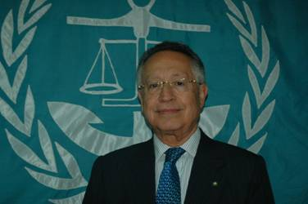
6. *H.E. Mr. Efthimios E. Mitropoulos*
7. *Secretary - General, IMO*
8. This academic year students from 24 States will graduate at IMLI. Since its establishment in 1988 to this day IMLI has trained 516 students from 115 states and territories around the world.
9. The Ceremony will be attended by many personalities, including The Hon. Dolores Cristina, Minister of Education, Culture, Youth and Sports, Ambassador Lino Vassallo, Executive Director, Merchant Shipping and Registrar General of Shipping and Seamen, and Permanent Representative of Malta to the IMO, Ms. Makiko Tanaka, Project Coordinator, Maritime Affairs, The Nippon Foundation, Professor Dr. Marko Pavliha, Professor of Commercial, Transport and Insurance Law, Faculty of Maritime Studies and Transportation, University of Ljubljana.
10. It is noteworthy that in his message to the IMLI graduates of the Class of 2009, H.E. Mr. Efthimios E. Mitropoulos said:
11. *“Given the environmental and economic problems the world is currently facing, the significance of international shipping as a cost-effective and ‘green’ form of transport has never been more marked. Shipping will support the global economy as it eventually recovers and will help to guarantee sustainable prosperity in the future. IMLI graduates will have an important role to play in ensuring this vital industry is effectively and fairly regulated.*
12. *May I, therefore, congratulate the graduating class of 2009 and wish them every success in their future endeavours. They join a band of illustrious predecessors, who count ministers of justice, attorneys general, chief justices, ambassadors, chief executives and senior corporate managers among their number. I have no doubt that the 2009 graduates will also be high achievers, whether in their own countries or on the international stage.”*
13. _________________________________
14. * *If you do not want to receive IMLI e-News in future, please return this message to the above address with request to DELETE in the subject field.*
15. *\*\* For further information please contact Ms. Elda Belja (Editor, IMLI e-News) at* [publications@imli.org](mailto:publications@imli.org)