Circulated in more than 100 States to personalities in the legal and maritime professions

IMLI e-News

The IMO International Maritime Law Institute Official Electronic Newsletter       (Vol.  6 , Issue No. 50)   11 May 2009

1. **IMLI CELEBRATES ITS 20TH ANNIVERSARY**
3. The IMO International Maritime Law Institute held a Commemorative Seminar to celebrate its 20th Anniversary at the IMO Headquarters in London on 5 May 2009.

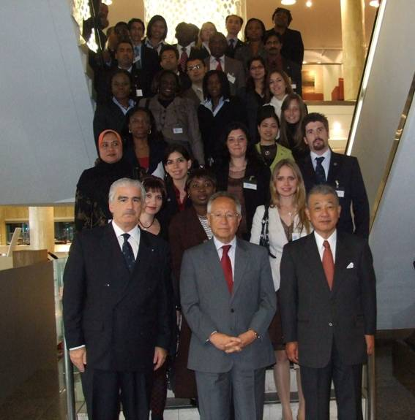

*H.E. Mr. Efthimios E. Mitropoulos (IMO Secretary-General), Professor David Attard (IMLI Director), Mr. Yohei Sasakawa (Chairman of the Nippon Foundation) and IMLI graduates*

The Panel of Speakers, which was presided by H.E. Mr. Efthimios E. Mitropoulos, Secretary-General of the International Maritime Organization (IMO), included Professor David Attard, IMLI Director, Professor Francis M.B. Reynolds Q.C, Barrister/Professor Emeritus, University of Oxford, Ambassador Lino Vassallo, Permanent Representative of Malta to IMO and Mr. Yohei Sasakawa, Chairman of the Nippon Foundation addressed the audience. The seminar was attended by distinguished guests including Mr. William A. O’Neil, Secretary-General Emeritus of IMO, IMLI Members of the Governing Board, Diplomatic Representatives and IMLI graduates.

The opening remarks were made by Professor David Attard, Director of IMLI. Professor Attard recalled that “IMLI was established in 1988 under an Agreement concluded between IMO and the Government of Malta and commenced its first academic year in October 1989.  It is sited in beautiful premises, on the University of Malta Campus, which was generously made available by the Government of Malta. The founders granted the Institute with an international legal personality and promulgated a Statute which declares that the Institute enjoys autonomy within the framework of the International Maritime Organization. IMLI was also given the right to enjoy academic freedom required for the achievement of its objectives, with particular reference to the choice of subjects covered and methods of instruction. Our Institute is governed by an active Board of Governors, under the Chairmanship of Mr. E. Mitropoulos. Governors are appointed on the basis of their outstanding expertise in the field of maritime law.”

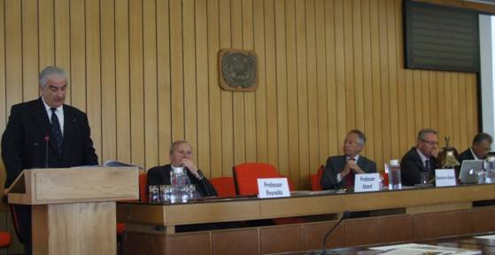

*Professor David Attard (IMLI Director) delivering the opening remarks*

He referred to the Institute’s objectives by stating that “The Institute, the first one of its type anywhere, offers a unique course designed to cover the whole spectrum of international maritime law. Its programme consists of numerous modules, which include international law, law of the sea, shipping law, marine environmental law, and legislation drafting. Training at the Institute also fosters excellence in three important areas:

1. 1. the development of expertise to advise on and develop national maritime legislation;
2. 2. the development of legislative drafting skills to ensure that States have the necessary expertise to incorporate international rules into legislation; and
3. 3. the preparation of lawyers to participate in, and contribute to, the deliberations of the international maritime fora.”

Professor Attard made specific reference to the recent developments that have taken place in connection with the Institute, in that it now offers programmes ranging from the Doctor of Philosophy in International Maritime Law to an Advanced Diploma for non-lawyers who wish to understand the major features of international maritime law.

Professor Attard expressed his appreciation that “IMLI has received widespread approval of its efforts to ensure that States are provided with the human expertise necessary to effectively serve the rule of international maritime law. This approval is reflected in the declarations adopted in many fora.

It is a matter of great pride that in November 2007 - the IMO Assembly adopted a resolution entitled “Research Work Undertaken by the IMO International Maritime Law Institute”. The resolution – by IMO’s highest authority - recognizes IMLI as a centre of academic excellence in the maritime legal field and expresses appreciation for its work, including its research activities.  [Member States, the IMO organs, international organizations and all other stakeholders of the global maritime community were urged to make use of the competencies of IMLI in commissioning legal research relating to their respective fields of activity and to take into account the findings and recommendations of research work undertaken by the Institute.]

It is a matter of great pride that last November the United Nations General Assembly adopted a Resolution (A/Res/63/111) which:

“Recognizes the importance of the work of the International Maritime Law Institute of the International Maritime Organization as a centre of education and training of Government legal advisers, mainly from developing States, notes that the number of its graduates in more than 102 States, confirms its effective capacity-building role in the field of international law, and urges States, intergovernmental organizations and financial institutions to make voluntary financial contributions to the budget of the Institute.”

Professor Attard observed that “We are pleased to note that IMLI graduates occupy senior positions in their country’s highest institutions. It gives me great pride to note that IMLI graduates are actively contributing to their country’s development. Many occupy senior and prestigious positions ranging from Ministers, Chief Justices, Judges, Magistrates, Attorney-Generals, University Professors, and legal advisers to Governments. In the international fora, IMLI graduates have demonstrated a similar aptitude for success. It is often possible to find them leading national delegations to IMO meetings and diplomatic conferences.”

Then, H.E. Mr. Efthimios E. Mitropoulos, Secretary-General of IMO delivered the keynote address. He noted that “…studying at IMLI not only provides a first rate academic education but also inculcates an ability to think and to act as an individual. It is said that “a mind, once stretched by a new idea, never regains its original dimensions.” For 20 years, students have been leaving IMLI with broader minds, richer experiences and the best possible preparation for the challenges of their future professional life.”

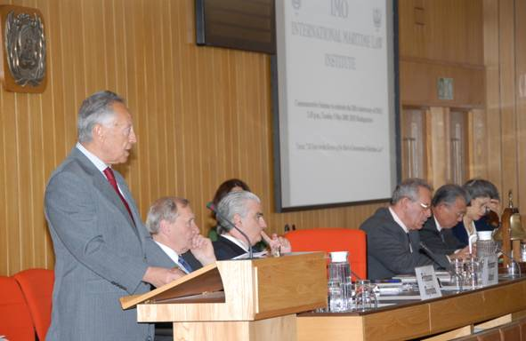

*H.E. Mr. Efthimios E. Mitropoulos (IMO Secretary-General) delivering his keynote address*

He recalled that it was Professor David Attard who first proposed the establishment of IMLI to the then Secretary-General of IMO, Dr. C.P. Srivastava; “One cannot talk of IMLI without speaking of one man in particular – the Institute’s esteemed Director, Professor David Attard, who not only was instrumental in its creation but who has been central to its development and growth ever since. In his capacity of Special Adviser to Dr. C.P. Srivastava, the then Secretary-General of IMO, it was Professor Attard who first proposed the establishment of the IMO International Maritime Law Institute to train lawyers from developing countries in private and public international maritime law.” He observed that “Dr. Srivastava whose vision was to bridge the gap between developed and developing countries, took up the suggestion enthusiastically. Thanks to his tireless efforts the Institute was launched in 1988 and started its first course in 1989. The same enthusiasm for, and dedication to, IMLI was shared by Mr. W.A. O’Neil, the next Secretary-General of IMO … and the rest, as the saying goes, is history.”

The Secretary-General further stated that “From those noble beginnings, IMLI has flourished and grown into the centre of academic excellence that we know today.  Central to the Institute’s educational offering is its specialized post-graduate course leading to the degree of Master of Laws (LL.M.) in International Maritime Law. Unlike many traditional programmes, the Institute’s LL.M. programme provides students with a specialized education in maritime law from a truly international perspective. Major legal systems, including the civil and common law systems, are comparatively considered in relation to maritime affairs.”

He expressed his gratitude to the Government of Malta as follows “And, of course, none of the Institute’s achievements would have been possible without the generous facilities provided by the host Government of Malta and the continued support of the Malta Maritime Authority. I offer them both my sincere thanks.”

He also paid tribute to the many donors, supporters and benefactors who, down the years, have provided funding, in-kind support and expertise necessary for the Institute’s continuing operation. The Secretary-General stated that “ it may seem invidious to single out any one of these, since there have been so many contributions and all have been very gratefully received, I feel special mention should be made of the Nippon Foundation, whose support for IMLI has been unstinting and outstanding over many years.”

In recognition of the contribution made by the Nippon Foundation a presentation of the IMLI Award “Award for Meritorious Contribution towards the Dissemination, Harmonization and Implementation of International Maritime Law” was made to Mr. Yohei Sasakawa, Chairman of the Nippon Foundation. As a result of his unwavering efforts a joint project between the two institutions entitled “Human Resources Development Project for the Advancement of a more effective Legal Order for the Oceans” was launched in 2003 demonstrating the full support of the Nippon Foundation to the Institute’s objectives.

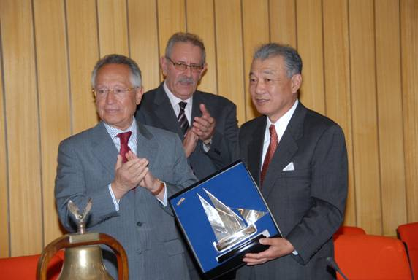

*Conferment of the IMLI Award “Award for Meritorious Contribution towards the Dissemination, Harmonization and Implementation of International Maritime Law” to Mr. Yohei Sasakawa (Chairman of the Nippon Foundation)*

In his address on “IMLI’s Role in Capacity Building” Mr. Sasakawa noted that “Six years ago, The Nippon Foundation launched a scholarship program to develop the human resources needed to promote a maritime legal order around the world. In these six years, we have provided scholarships to 56 recipients in 32 countries. I am very proud that our program has contributed, even in a modest way, to the development of IMLI and the international maritime community. I am equally proud that our efforts in support of IMO and the Institute’s development are being recognized in this way. I am well aware, however, that in receiving this award, we are also being encouraged to make even greater contributions to the Institute’s development in the years ahead. I am very pleased, naturally, to accept this award along with the commitment that it implies.”

He further stated that “I would like to express my highest praise and deepest appreciation for the contributions made to the maritime community by the Institute’s 465 graduates. Praise also goes to the IMO and IMLI for the research that they have enabled during the past 20 years. Further, I must mention the specialists in global maritime law and laws of the sea, who have cooperated as visiting professors since the Institute’s founding. They are an invaluable asset not only for the Institute, but also for the future development of international marine order.”

An address on the “Academic Prospects of IMLI” was delivered by Professor Francis M.B. Reynolds Q.C, Barrister/Professor Emeritus, University of Oxford. Professor Reynolds, a longstanding friend and supporter of IMLI, observed that  “I believe that the value of the IMLI Master’s degree conferred on its students on Saturday is that it makes those already concerned, or about to be concerned, with maritime matters aware of the breadth of the topic, of the many technical fields involved. In some of those fields they will have become skilled (or may already have been skilled when they arrived); as regards others they will finish the course knowing the pitfalls and traps to be avoided in the overall pursuit of preserving the rule of international maritime law and preserving the lives and livelihoods of sailors the world over. It is of course to the latter topic that the IMO, whose Institute this is, is dedicated.”

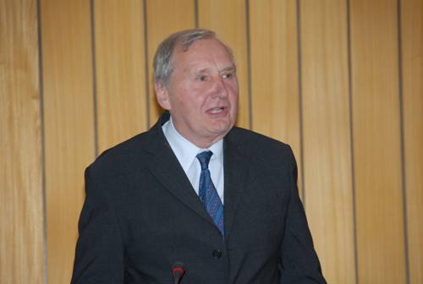

*Professor Francis M.B. Reynolds Q.C. (Barrister/Professor Emeritus, University of Oxford) delivering his address on “Academic Prospects of IMLI”*

Professor Reynolds concluded by stating that “In my view the IMO, the Government of Malta, the Nippon Foundation and other supporters such as the CMI are to be congratulated on supporting the institution now celebrating its 20th birthday. We must congratulate the students also on successful completion of the course, and we know that they will now be adding to what has for twenty years been a worldwide IMLI fraternity. Finally, we must not forget thanks to the small but lively band of people who run the place, starting with Professor Attard (assisted by his valued secretary Josephine), and taking in the rest of the staff, academic, administrative and domestic...”

Ambassador Lino Vassallo addressed the audience on behalf of IMLI’s Host State, the Government of Malta.

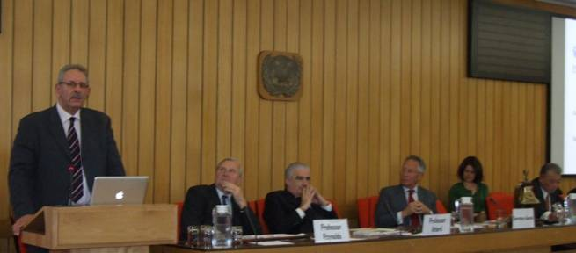

*Ambassador Lino Vassallo (Permanent Representative of Malta to IMO) delivering his address on behalf of IMLI’s Host State, the Government of Malta*

1. _________________________________
2. * *If you do not want to receive IMLI e-News in future, please return this message to the above address with request to DELETE in the subject field.*
3. *\*\* For further information please contact Ms. Elda Belja (Editor, IMLI e-News) at* [publications@imli.org](mailto:publications@imli.org)