Circulated in more than 100 States to personalities in the legal and maritime professions

IMLI e-News

The IMO International Maritime Law Institute Official Electronic Newsletter       (Vol.  6 , Issue No. 51)   14 May 2009

* 1. **THE IMO SECRETARY-GENERAL DELIVERS THE KEYNOTE ADDRESS DURING THE COMMEMORATIVE SEMINAR CELEBRATING IMLI’S 20TH ANNIVERSARY**

2. The IMO International Maritime Law Institute held a Commemorative Seminar to celebrate its 20th Anniversary at the IMO Headquarters in London on 5 May 2009.

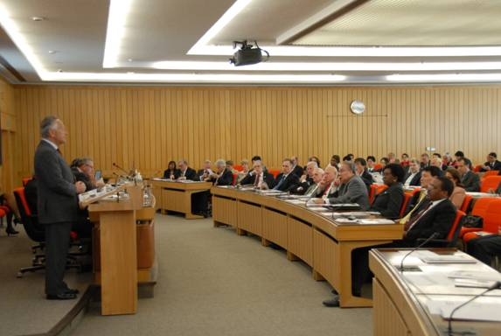

*H.E. Mr. Efthimios E. Mitropoulos (IMO Secretary-General) delivering the keynote address*

H.E. Mr. Efthimios E. Mitropoulos, Secretary-General of IMO delivered the keynote address as follows:

**IMLI 20th Anniversary Commemorative Seminar**

**IMO Headquarters, 5 May 2009**

**Speech by Efthimios E. Mitropoulos**

**Secretary-General, International Maritime Organization**

Excellencies, Permanent Representatives to IMO, Secretary-General Emeritus, Dr. Sasakawa, Professor Reynolds, IMLI Director, Governors, Distinguished guests, IMLI Graduates, Media representatives, Ladies and gentlemen,

It gives me great delight to welcome you here today and I consider it a genuine privilege to open this event in which, on the occasion of its 20th anniversary, we will pay tribute to the International Maritime Law Institute – one of the great success stories of IMO.

Last Saturday, along with many dignitaries present here today, I assisted at the 20th IMLI graduation ceremony in the Institute’s motherland, Malta, at which yet another fresh batch of graduates bid farewell to their home-from-home for the past year, fully equipped with the skills and knowledge they need to succeed in the professional arena.  This has become a familiar and very welcome task for me, as it was for my predecessors – one that I cherish enormously and look forward to with anticipation every year.

Indeed, so regular is the process and so reliable the end-product that it is tempting to think of the Institute as a kind of legal conveyor belt; but this would be to miss the point that studying at IMLI not only provides a first rate academic education but also inculcates an ability to think and to act as an individual.  It is said that “a mind, once stretched by a new idea, never regains its original dimensions.”  For 20 years, students have been leaving IMLI with broader minds, richer experiences and the best possible preparation for the challenges of their future professional life.  This year’s graduates, the class of 2008/2009, who I am delighted to see here present today, are not an exception.

So let us look back 20 years, to a world without IMLI.  Then, as now, IMO was responsible for a sizeable body of international treaties and several other legal instruments.  Then, as now (with one exception), the Organization did not have the power to ensure the effective implementation of these important international measures.  Instead, their enforcement depended on States which, generally, have to incorporate IMO measures into their domestic law.  In the 1980s, however, many Governments, particularly in the developing world, were experiencing difficulties in this respect, due largely to a lack of appropriate legal expertise at the national level.  This problem, understandably, became one of great concern to IMO.

One cannot talk of IMLI without speaking of one man in particular – the Institute’s esteemed Director, Professor David Attard, who not only was instrumental in its creation but who has been central to its development and growth ever since.  In his capacity of Special Adviser to Dr. C.P. Srivastava, the then Secretary-General of IMO, it was Professor Attard who first proposed the establishment of the IMO International Maritime Law Institute to train lawyers from developing countries in private and public international maritime law.  Dr. Srivastava, whose vision was to bridge, to the extent possible, the gap between developed and developing countries, took up the suggestion enthusiastically, as did the membership of IMO.  Thanks to his tireless efforts, the Institute was launched in 1988 and started its first course in 1989.  The same enthusiasm for, and dedication to, IMLI was shared by Mr. W.A. O’Neil, the next Secretary-General of IMO … and the rest, as the saying goes, is history.

From those noble beginnings, IMLI has flourished and grown into the centre of academic excellence that we know today.  Central to the Institute’s educational offering is its specialized post-graduate course leading to the degree of Master of Laws (LL.M.) in International Maritime Law.

Unlike many traditional programmes, the Institute’s LL.M. programme provides students with a specialized education in maritime law from a truly international perspective.  Major legal systems, including the civil and common law systems, are comparatively considered in relation to maritime affairs.

Particular emphasis is placed on the international regulatory framework developed by IMO to ensure maritime safety and security and the protection of the marine environment.  But the programme also covers commercial law aspects of shipping, including the carriage of goods by sea and marine insurance as well as public international law and the law of the sea.

Crucial, from the IMO perspective, the programme is designed to provide training in the development and drafting of maritime legislation.  Intensive drafting exercises are carried out taking into account both the international law on the given subject as well as national maritime policies and objectives.

Although candidates for the LL.M. programme are usually officially nominated by their Governments or national administrations, the comprehensive and interdisciplinary character of the programme also equips graduates to serve in non-governmental bodies, such as the legal departments of port authorities, shipping companies and organizations providing legal advisory services to Governments and shipping concerns.

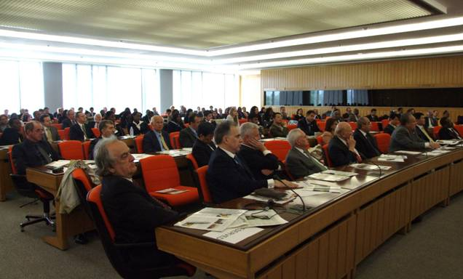

In addition to the LL.M programme, IMLI now also offers a programme leading to the Degree of Doctor of Philosophy in International Maritime Law, as well as a series of short courses aimed at those seeking to update their knowledge of current developments in particular areas of maritime law.

And, in a very recent development, I was delighted to learn, last Thursday, that the Government of Malta has announced that it now officially recognizes all qualifications awarded by IMLI, through its Ministry of Education, Culture, Youth and Sports. This means that IMLI’s qualifications will be formally recognized by educational authorities throughout the world – which is very good news for all concerned, not least, for today’s graduands.

IMLI justifiably prides itself on the international and multi-cultural nature of its campus life.  In this respect, it is a very special institution.  On the one hand, its international faculty (composed of around 50 professors and lecturers drawn from leading international organizations, universities and firms, who visit the Institute throughout the programme) brings the legislative and judicial experience of so many diverse maritime jurisdictions directly to the classroom – an invaluable asset, and one which is supported by an excellent resident faculty providing day-to-day teaching of the programme and supervision of students’ progress.

And, on the other hand, the student body itself draws candidates from across the globe.  Time spent at IMLI promotes a spirit of mutual understanding and co-operation between cultures, paving the way for future collaboration between graduates in combining efforts towards maritime law unification.  Thus far, a total figure of 477 students, from 116 countries and territories world-wide, have undertaken training at the Institute, in the course of which they have each participated not just in an educational programme but also in what the IMLI website so aptly describes as “an exciting, inter-cultural journey”.

Ladies and gentlemen,

As IMLI celebrates its 20th anniversary in full-scale operation, I should like to express my deep appreciation for the Institute’s successes as a whole and, to the Director and the dedicated teaching and administrative staff in particular, my thanks for their contribution in imparting invaluable knowledge and expertise to the benefit of students, their Governments and the maritime community at large.

I should also like to take this opportunity to pay tribute to the many donors, supporters and benefactors who, down the years, have provided funding, in-kind support and expertise necessary for the Institute’s continuing operation.  In acknowledging these many contributions, all of which have been very gratefully received, I wish to make special mention of Dr. Sasakawa and the Nippon Foundation, whose leadership and support for IMLI have been outstanding over many years and will be deservedly recognized with the presentation of a special award in a few moments.

And, of course, none of the Institute’s achievements would have been possible without the continuing dedication and application of the Institute’s Governing Board, which has provided a foundation of solid governance for the Institution since the outset.  The generosity of the host Government of Malta, the excellent facilities provided and the unstinting support of the Malta Maritime Authority have earned our admiration and gratitude.  I offer them both my sincere thanks.

Indeed, my thanks go to all the many donors and supporters – and, to those who may still be considering whether or not to join their ranks, I draw their attention to resolution 63/111 of the United Nations General Assembly, on Oceans and the law of the sea, which was adopted in December 2008.  Not only did this formally recognize the importance of IMLI’s work as a centre of education and training – high praise indeed from such an august body – but it also urged States, intergovernmental organizations and financial institutions to make financial contributions to the Institute’s budget: I sincerely hope that message will be taken to heart and acted upon.

And so to conclude: over the years, IMLI has produced a superlative body of expert and qualified maritime lawyers who are now, collectively, making a very positive and valuable contribution in pursuance of the causes espoused by IMO: safe, secure and efficient shipping on clean oceans.  Ministers of justice, attorneys general, chief justices, ambassadors, chief executives and senior corporate managers can all be found among their number – not to mention delegates to the IMO Legal Committee.

Today, IMLI remains a lasting and greatly valued testimony to the foresight, diligence and tenacity not only of its visionary founders, but also of the many others who have followed in their wake.  Studying at IMLI provides students from developing countries with a unique opportunity to embrace the international nature of maritime law in a multicultural environment under the guidance of world-renowned professors and lecturers.  Its contribution has been, and continues to be, immense.

Given the environmental and economic problems the world is currently facing, the significance of international shipping as a cost-effective and ‘green’ form of transport has never been more marked.  Shipping will support the global economy as it eventually recovers and will help to guarantee sustainable prosperity in the future.  IMLI graduates, past and future, will have a key role to play in ensuring this vital industry is effectively and fairly regulated.  Thus, IMLI remains as relevant today as it ever has been, and I wish the Institute – and all devoted to and involved in its laudable work – every success and good fortune as you embark upon the next 20 years.

Thank you.

1. _________________________________
2. * *If you do not want to receive IMLI e-News in future, please return this message to the above address with request to DELETE in the subject field.*
3. *\*\* For further information please contact Ms. Elda Belja (Editor, IMLI e-News) at* [publications@imli.org](mailto:publications@imli.org)