Circulated in more than 100 States to personalities in the legal and maritime professions

IMLI e-News

The IMO International Maritime Law Institute Official Electronic Newsletter       (Vol.  6 , Issue No. 52)   15 May 2009

* 1. **THE IMLI DIRECTOR DELIVERS THE OPENING REMARKS DURING THE COMMEMORATIVE SEMINAR CELEBRATING IMLI’S 20TH ANNIVERSARY**



At the Commemorative Seminar to celebrate IMLI’s 20th Anniversary held at the IMO Headquarters in London on 5 May 2009, Professor David Attard, Director of IMLI delivered the opening remarks as follows:

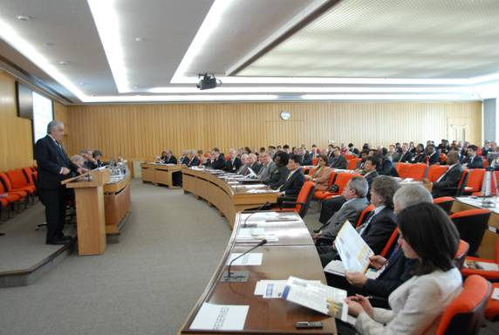

*Professor David Attard delivering the opening remarks*

**COMMEMORATING THE 20TH YEAR IN THE SERVICE OF INTERNATIONAL MARITIME LAW**

**ADDRESS BY PROFESSOR DAVID J. ATTARD, DIRECTOR, IMO IMLI**

**AT A SEMINAR HELD BY THE SECRETARY-GENERAL OF IMO,**

**MR. E.E. MITROPOULOS, TO COMMEMORATE THE 20TH ANNIVERSARY OF IMLI’S ACADEMIC ESTABLISHMENT**

***IMO HEADQUARTERS, LONDON, TUESDAY, 5 MAY 2009 AT 2:45 P.M.***

Secretary-General,

IMLI Governors,

Excellencies,

IMLI Graduates,

Distinguished Guests,

On behalf of the IMO International Maritime Law Institute, I wish to state, at the very outset, what a great privilege and honour it is to address you today as its Director. I am particularly grateful for your presence and interest. I am glad that you have found the time to share with us this joyful occasion.

IMLI was established in 1988 under an Agreement concluded between IMO and the Government of Malta and commenced its first academic year in October 1989. It is sited in beautiful premises, on the University of Malta Campus, which was generously made available by the Government of Malta. The founders granted it with an international legal personality and promulgated a Statute which declares that the Institute enjoys autonomy within the framework of the International Maritime Organization. IMLI was also given the right to enjoy academic freedom required for the achievement of its objectives, [with particular reference to the choice of subjects covered and methods of instruction]. Our Institute is governed by a formidable Board of Governors, under the Chairmanship of Mr. E. Mitropoulos. Its members are appointed primarily on the basis of their outstanding expertise in the field of maritime law.

The Institute, the first one of its type anywhere, offers a unique course designed to cover the whole spectrum of international maritime law. Its programme consists of numerous modules, which include international law, law of the sea, shipping law, marine environmental law, and legislation drafting. Training at the Institute also fosters excellence in three important areas:

1. the development of expertise to advise on and develop national maritime legislation;
2. the development of legislative drafting skills to ensure that States have the necessary expertise to incorporate international rules into domestic legislation; and
3. the preparation of lawyers to participate in, and contribute to, the deliberations of the international maritime fora.

In order to qualify, students – who primarily should come from developing States – are required to have a first law degree. A major and innovative feature of the Institute is that 50 per cent of the places on the course each year are reserved for women candidates.

The duration of the course is one academic year and successful students are awarded a Masters Degree in International Maritime Law.

IMLI students are required to undertake one of the most intensive international maritime law courses available worldwide. IMLI’s teaching staff faces the fascinating challenge of training lawyers from diverse cultures, and different legal systems of the world. The Anglo-Saxon, Roman-Germanic, Civil Law and Sharjah legal cultures have all been represented in our courses.  For months, the participants live together and are required to undertake – with almost monastic dedication – studies which are designed to transcend this diversity and educate the intellect in the pursuit for uniform maritime legislation implementing IMO Conventions.

More recently the Institute offers other Programmes of Study, ranging from the Doctor of Philosophy in International Maritime Law to an Advanced Diploma for non-lawyers who wish to understand the major features of international maritime law.

Distinguished Guests,

IMLI’s small permanent, teaching staff is complemented annually by a formidable list of eminent practitioners and authoritative academics in the field of international maritime law, who represent the world’s main legal systems. We feel this is important as it offers our students the opportunity to learn maritime law on a comparative basis.

The cornerstone of any academic institution is its reputation. At IMLI we are conscious of the need to ensure that our training and teaching conform to the highest standards which need to be maintained if we are to preserve our reputation as a centre of excellence. I feel it is reasonable to assert that our academic accomplishment is reflected in the confidence demonstrated by 115 Governments who have sent their finest officials to train at IMLI.

This academic success is the result of various practices that have been put in place, such as the appointment of independent external examiners and cooperation with members of leading academic institutions such as the Universities of Oxford, Yale and the Sorbonne.

Furthermore, our linkage with IMO provides us with access to the most competent expertise in shipping available throughout the world.  With IMO’s assistance, IMLI continues to seek to fine-tune its syllabus to reflect the latest developments in international maritime law.

We also have a fruitful cooperation with the Comité Maritime International that assists us in our efforts to attract leading practitioners to lecture at IMLI.

We are particularly proud of our Project entitled “Human Resources Development Project for the Advancement of a More Effective Global Legal Order for the Oceans” with the Nippon Foundation. It has enabled lawyers from all over the world – particularly from Asia - to undertake their studies at IMLI. We are immensely grateful to Mr. Yohei Sasakawa, under whose guidance the Nippon Foundation is effectively, through developing human expertise, contributing to the development of international maritime law.

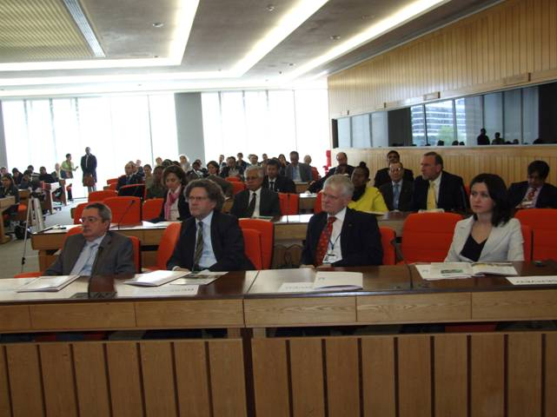

Distinguished Guests,

It is well known that the success of international maritime conventions and similar legal instruments is – to a large extent – dependent on the will of States. The viability of these texts depends generally on whether States are themselves prepared, through national laws, to enforce the rules therein. In view of the global nature of such a task, it is important to bear in mind that not all States have the knowledge, experience or resources of the traditional maritime States. Indeed, it has also been noted that although many developing States have reasonable numbers of legal trained persons, they generally do not have a sufficient number of lawyers trained in international maritime law.

Essentially, IMLI’s work over these past 20 years has been designed to respond to this deficiency.  IMLI has received widespread approval of its efforts to ensure that States are provided with the human expertise necessary to effectively serve the rule of international maritime law. This approval is reflected in the declarations adopted in many fora.  I wish however this afternoon to focus on just a few. The IMO Flag State Implementation Sub-Committee declared in a unanimous decision that IMLI played an “important role in IMO’s efforts to enhance the implementation of the various IMO standards worldwide.”

It is a matter of great pride that in November 2007 - the IMO Assembly adopted a resolution entitled “Research Work Undertaken by the IMO International Maritime Law Institute”. The resolution – by IMO’s highest authority - recognizes IMLI as a centre of academic excellence in the maritime legal field and expresses appreciation for its work, including its research activities.  [Member States, the IMO organs, international organizations and all other stakeholders of the global maritime community were urged to make use of the competencies of IMLI in commissioning legal research relating to their respective fields of activity and to take into account the findings and recommendations of research work undertaken by the Institute.]

It is a matter of great pride that last December the United Nations General Assembly adopted a Resolution (A/Res/63/111) which:

“Recognizes the importance of the work of the International Maritime Law Institute of the International Maritime Organization as a centre of education and training of Government legal advisers, mainly from developing States, notes that the number of its graduates in more than 102 States, confirms its effective capacity-building role in the field of international law, and urges States, intergovernmental organizations and financial institutions to make voluntary financial contributions to the budget of the Institute.”

It is with great satisfaction that I am able to report that [over the past twenty years 463 lawyers from 112 States and territories, from both the developing and the developed world, have completed successfully their LL.M. studies at IMLI.] Today, there is hardly a major port in the developing world, wherein the maritime community will not find the expertise of an IMLI graduate, who is able to understand and speak the language of international maritime law. It seems to me no exaggeration to state that IMLI is a generating unique and formidable global network of lawyers, which has already started to influence the development of international maritime law. I am pleased to announce that IMLI graduates have set up a Pacific Regional Association which is actively participating in the progressive development and codification of international maritime law within Asia and internationally. In fact, the Executive Council of the ‘Pacific International Maritime Law Association’ (PIMLA) has asked me to convey its best wishes to the participants of this Seminar.

We are pleased to note that IMLI graduates occupy senior positions in their country’s highest institutions.  It gives me great pride to note that IMLI graduates are actively contributing to their country’s development. Many occupy senior and prestigious positions ranging from Ministers, Chief Justices, Judges, Magistrates, Attorney-Generals, University Professors, and legal advisers to Governments.

In the international fora, IMLI graduates have demonstrated a similar aptitude for success. It is often possible to find them leading national delegations to IMO meetings and diplomatic conferences. The Vice-Chairmanship of the IMO Legal Committee and International Oil Pollution Compensation Funds are just two of the notable international posts to which IMLI graduates have been elected. IMLI’s contribution to the international maritime community is vividly reflected in a statement issued at the Geneva Diplomatic Conference on Arrest of Ships.  In this declaration eight IMLI graduates who were representing their country, expressed their appreciation and gratitude for their studies at IMLI, which have enabled them to contribute effectively towards the codification and progressive development of international maritime law.

It is these individual successes that illuminate our work and inspire us to move forward. They confirm, in my view, the wisdom of IMLI’s founding fathers, in particular Dr. C.P. Srivastava and Dr. Joe Fenech. IMLI’s achievements will remain a monument to their impressive foresight and dedication to the cause of international maritime law.

I also wish to recognise the support of Secretary-General Emeritus O’Neil. It was critical in the years when there were those who questioned IMLI’s viability and role. It was therefore significant when after considerable work and effort, he was able to characterise IMLI as an outstanding success and to recognize it “as an indispensible part of the international system of maritime law”.

I also wish to record my gratitude for the great support and generosity of the current Secretary-General, who over the past years has, despite his many commitments, supported the work of IMLI. We are extremely honoured to read that Mr. Mitroupolos was able to write recently:

*“….*over the years, IMLI has produced a body of expert and qualified maritime lawyers who are now, collectively, making a very positive and valuable contribution in pursuance of the causes espoused by IMO – safe, secure and efficient shipping on clean oceans. In pursuing its noble educational objectives, IMLI has drawn praise from the highest quarters.*”*

I hope, in my address, I have managed to transmit to you some of the important features of our exciting work and its global ramifications in the service of international maritime law. I wish to conclude by expressing my gratitude to all who have helped in ensuring that IMLI provides excellent and unique training in the field of international maritime law.

Finally I wish to address our graduates: Your achievements will continue to embellish the Institute’s academic reputation. We are proud of your efforts and confident that you will utilise the knowledge and training you have received in the service of the rule of international maritime law.

Thank you very much.

1. _________________________________
2. * *If you do not want to receive IMLI e-News in future, please return this message to the above address with request to DELETE in the subject field.*
3. *\*\* For further information please contact Ms. Elda Belja (Editor, IMLI e-News) at* [publications@imli.org](mailto:publications@imli.org)