Circulated in more than 100 States to personalities in the legal and maritime professions

IMLI e-News

The IMO International Maritime Law Institute Official Electronic Newsletter       (Vol.  6 , Issue No. 53)   18 May 2009

* 1. **OXFORD UNIVERSITY PROFESSOR’S ADDRESS DURING THE COMMEMORATIVE SEMINAR CELEBRATING IMLI’S 20TH ANNIVERSARY**

2. At the Commemorative Seminar to celebrate IMLI’s 20th Anniversary held at the IMO Headquarters in London on 5 May 2009, Professor Francis M.B. Reynolds Q.C., Barrister/Professor Emeritus, University of Oxford delivered an address on “Academic Prospects of IMLI” as follows:

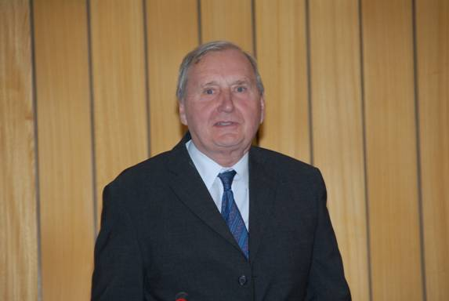

*Professor Francis M.B. Reynolds Q.C., delivering his address on “Academic Prospects of IMLI”*

**COMMEMORATING THE 20TH YEAR IN THE SERVICE OF INTERNATIONAL MARITIME LAW**

**ADDRESS BY PROFESSOR** **FRANCIS M.B. REYNOLDS Q.C., BARRISTER/PROFESSOR EMERITUS, UNIVERSITY OF OXFORD**

**AT A SEMINAR HELD BY THE SECRETARY-GENERAL OF IMO,**

**MR. E.E. MITROPOULOS, TO COMMEMORATE THE 20TH ANNIVERSARY OF IMLI’S ACADEMIC ESTABLISHMENT**

***IMO HEADQUARTERS, LONDON, TUESDAY, 5 MAY 2009 AT 2:45 P.M.***

I feel much honoured to be asked to speak in such august company as the Secretary-General, and Ambassador Vassallo, to say nothing of Professor Attard, on this auspicious occasion which marks 20 years of consistent achievement on the part of IMLI. I have now been visiting IMLI for 12 years (though I did miss one). I was first introduced by Mr Bill Birch Reynardson of the C.M.I., which has long been a supporter of IMLI; Mr Birch Reynardson, with others, was at the time very active in making that support practical. In fact he came and sat in the front row at the first lecture I gave, which initially somewhat alarmed me, but I suppose I must have passed the test because I have kept on being invited.

What I have seen is a remarkable development over the years. It is no disrespect to previous generations of students to say that they seem to get better each year: I said this last year and I say it again now.

In a sense I am repeating what previous speakers have said both today, and in visits during the year reported on the web. But I make no apology for saying again that I believe the function performed by IMLI is a most valuable contribution to the international maritime community.

If one looks at the syllabus through which the students are taken (I almost said, which is inflicted on the students) one can only say that the coverage is immense. Although Professor Attard and the Secretary-General have made reference to these, I give now an extended version. It ranges from straight private shipping contracts for carriage by sea and marine insurance, and the specific maritime additions as to collisions, salvage, general average, towage, pilotage, tonnage limitation and ship arrest to the public international law of the sea and the law of international institutions, environmental law, maritime labour law, international safety and regulation and security.

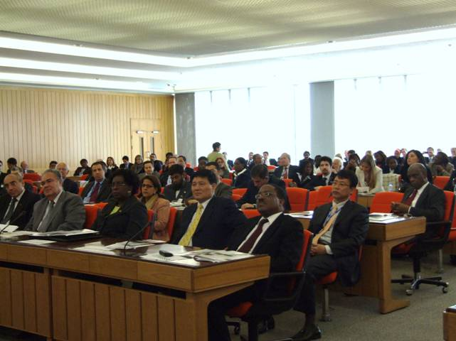

Few if any people could be expert in all these topics; but any person seriously involved in maritime matters at governmental level must be at the very least quite fully aware of their existence, outline and structure, and must know how to find out, quickly, more about anything they encounter which is significant but unfamiliar. An example is piracy: to how many of us had it occurred before recent events that there may on the present state of affairs be nothing to do with pirates but release them? Taking them far away to the arresting country may be of doubtful value and they may sometimes even regard this as a benefit.

I believe that the value of the IMLI Master’s degree conferred on its students on Saturday is that it makes those already concerned, or about to be concerned, with maritime matters aware of the breadth of the topic, of the many technical fields involved. In some of those fields they will have become skilled (or may already have been skilled when they arrived); as regards others they will finish the course knowing the pitfalls and traps to be avoided in the overall pursuit of preserving the rule of international maritime law and preserving the lives and livelihoods of sailors the world over. It is of course to the latter topic that the IMO, whose Institute this is, is dedicated.

As has already been described, the students, in addition to taking in the broad coverage I have listed, prepare research papers, often on matters relevant to their own jurisdiction, and engage in drafting exercises. Despite differences in language, these are surely a most valuable part of the course for people who may themselves become involved in drafting, or its scrutiny. The process is overseen by an external examiner in accordance with normal university procedure; and the students have the use of an excellent and well-run library of which I remember Professor Tetley saying to me: “And all this is for 30 students?”

Over and above the formal course itself, a long line of distinguished personages from the shipping world visit and share their experience with those on the course – finishing this year with the Secretary-General of the United Nations, whose office is not of course directed to shipping but who stands as a symbol of international cooperation.

I should note also that the Institute confers other qualifications: an Advanced Diploma, and a Doctorate, of which the second was obtained this year by Dr Patricia Mallia, an old friend of the Institute. It concerns “Migrant Smuggling by Sea”, a public international law topic highly relevant in Malta at this time, and of course not only there.

In my view the IMO, the Government of Malta, the Nippon Foundation and other supporters such as the CMI are to be congratulated on supporting the institution now celebrating its 20th birthday. We must congratulate the students also on successful completion of the course, and we know that they will now be adding to what has for twenty years been a worldwide IMLI fraternity. Finally, we must not forget thanks to the small but lively band of people who run the place, starting with Professor Attard (assisted by his valued secretary Josephine), and taking in the rest of the staff, academic, administrative and domestic – and if I may be permitted an in-joke that not everyone present will understand, not forgetting the cats, who while they come into none of these categories are certainly a conspicuous feature of the institution.

1. _________________________________
2. * *If you do not want to receive IMLI e-News in future, please return this message to the above address with request to DELETE in the subject field.*
3. *\*\* For further information please contact Ms. Elda Belja (Editor, IMLI e-News) at* [publications@imli.org](mailto:publications@imli.org)