Circulated in more than 100 States to personalities in the legal and maritime professions
IMLI e-News
The IMO International Maritime Law Institute Official Electronic Newsletter (Vol. 6, Issue No. 54) 22 May 2009

FORMER FOREIGN AFFAIRS MINISTER WRITES ON IMLI’S 20TH ANNIVERSARY COMMEMORATIVE SEMINAR

Dr Michael Frendo, Malta’s Former Minister of Foreign Affairs and Former Minister Responsible for Shipping was one of the many distinguished guests that attended the Commemorative Seminar to celebrate IMLI’s 20th Anniversary held at the IMO Headquarters in London on 5 May 2009.
On the occasion, Dr Frendo published an article entitled “Malta's maritime vocation” to the Times of Malta, on Thursday, 21 May 2009.
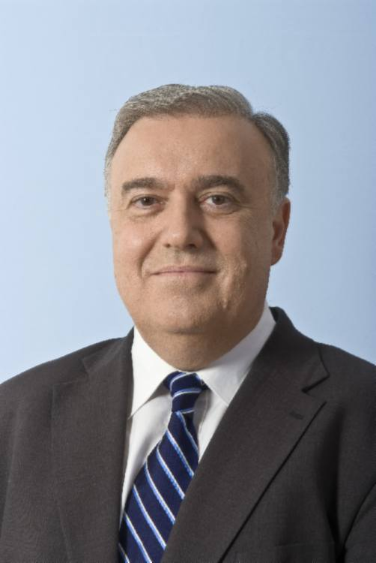
Dr Michael Frendo
Dr Frendo introduces the reader to the event by noting that “There was a sea of contentment in the impressive hall of the International Maritime Organization Headquarters in London in the celebration of 20 years from the founding of its International Maritime Law Institute, run at the University of Malta campus, by its founding director David Attard.”
He further states that “This institute, the first of its kind anywhere in the world, has been responsible for the postgraduate formation of maritime lawyers from all over the world, many of whom today occupy major roles in their own countries. IMLI, as it is known to all, has been and continues to be a major contributor to the international rule of law, to the regulation of the maritime world and to development. Over these two decades, it has made a major contribution to the legal infrastructure of international maritime law in most of the countries of the world.”
Dr Frendo highlights that “A brainchild of Prof. Attard, the project was supported by (then) IMO Secretary-General Chandrika Prasad Srivastava and ably fashioned and enthusiastically pushed through by the late Minister Joseph Fenech, without whom overcoming traditional bureaucratic resistance might not have been possible. Dr Fenech remained dedicated to, and active in, IMLI throughout his life, well after he had relinquished public office. IMLI remains today the best living monument to the foresight of these three gentlemen.”
“Over these years, the institute has been driven to success by Prof. Attard and, in the words of Mr Mitropoulos, "one cannot talk of Imli without speaking of one man in particular - the institute's esteemed director, Professor David Attard, who not only was instrumental in its creation but who has been central to its development and growth ever since".”
He recalled that “This Maltese initiative in the maritime field has been a lasting success, not least because it has been nurtured and developed with top-class lecturing and results spreading Malta's name across the oceans. This has also had positive collateral effects on Malta's diplomatic reach, with many a contact from IMLI alumni on occasion being put at the service of Malta's diplomatic service - from the Seychelles to India, from Nigeria to the Kingdom of Tonga.
As rightly put by Malta's Permanent Representative to the International Maritime Organization, Ambassador Lino Vassallo, long-serving and ever so strongly authoritative in that organization, IMLI and Malta are irrevocably tied together, further enhancing Malta's image in the maritime field.”
Dr Frendo concluded his article by stating that “IMLI represents living proof of Malta's commitment to the system of the United Nations Organization and to serve the rule of international maritime law. The jam-packed hall at the IMO commemorative seminar in London with the participation of ministers, ambassadors, the former Secretary-General of IMO William O'Neill, former ministers, parliamentarians and IMLI alumni and fresh graduands from across the world bore witness to the deep appreciation and respect for IMLI's achievements. May its success continue.”
Dr Michael Frendo was first elected to the House of Representatives of Malta in 1987. From 1990 to 1992 he was Parliamentary Secretary for Youth, Culture and Consumer Protection and from 1992 to 1994 he was Minister of Youth and Arts.
From 1994 to 1996 Dr Frendo held the position of Minister of Transport, Communications and Technology. He was Parliamentary Secretary (Minister of State) in the Ministry of Foreign Affairs from March to July 2004 before becoming Minister of Foreign Affairs, position which he held until 2008.

_________________________________

* If you do not want to receive IMLI e-News in future, please return this message to the above address with request to DELETE in the subject field.
** For further information please contact Ms. Elda Belja (Editor, IMLI e-News) at publications@imli.org

