Circulated in more than 100 States to personalities in the legal and maritime professions

IMLI e-News

The IMO International Maritime Law Institute Official Electronic Newsletter       (Vol.  6 , Issue No. 55)   1 June 2009

* 1. **MALTA’S PERMANENT REPRESENTATIVE TO IMO ADDRESS DURING THE COMMEMORATIVE SEMINAR CELEBRATING IMLI’S 20TH ANNIVERSARY**

2. At the Commemorative Seminar to celebrate IMLI’s 20th Anniversary held at the IMO Headquarters in London on 5 May 2009, Ambassador Lino Vassallo, Malta’s Permanent Representative to IMO delivered an address as follows:

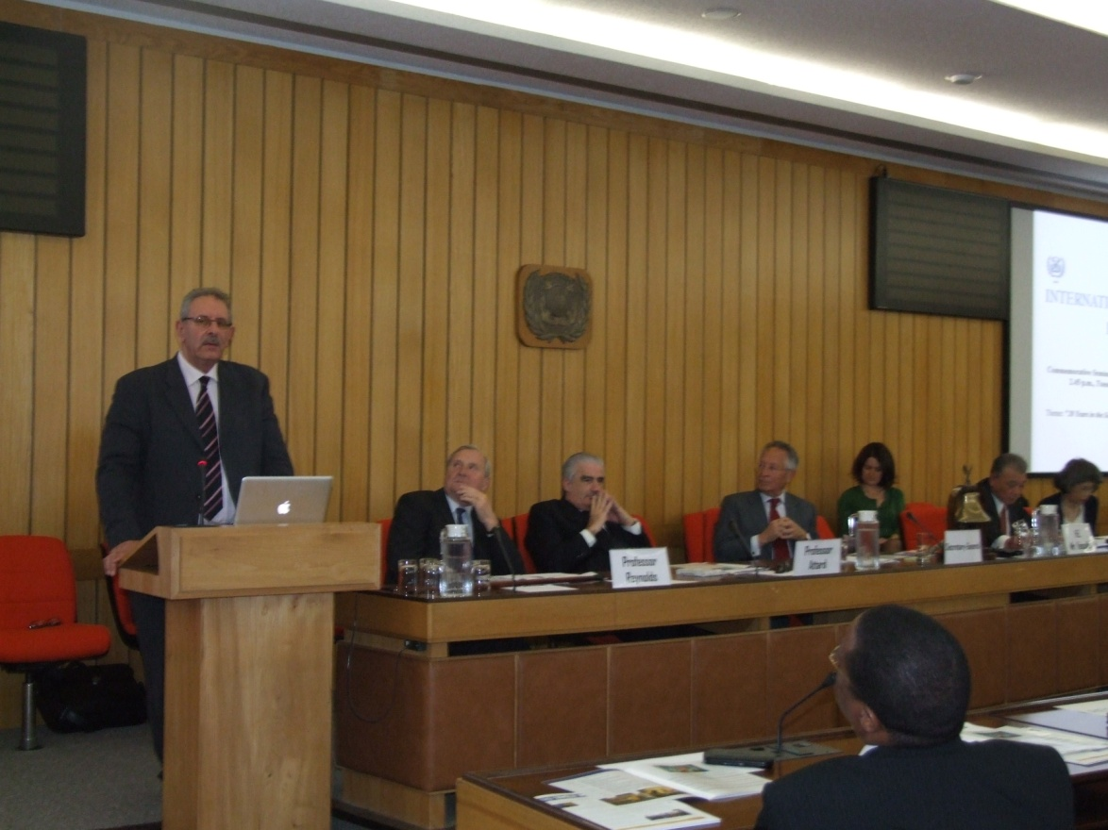

*Ambassador Lino Vassallo delivering his address*

**COMMEMORATING THE 20TH YEAR IN THE SERVICE OF INTERNATIONAL MARITIME LAW**

**ADDRESS BY MR LINO C VASSALLO   
PERMANENT REPRESENTATIVE OF MALTA TO INTERNATIONAL MARITIME ORGANISATION**

**AT A SEMINAR HELD BY THE SECRETARY-GENERAL OF IMO,**

**MR. E.E. MITROPOULOS, TO COMMEMORATE THE 20TH ANNIVERSARY OF IMLI’S ACADEMIC ESTABLISHMENT**

***IMO HEADQUARTERS, LONDON, TUESDAY, 5 MAY 2009 AT 2:45 P.M.***

Mr Secretary-General, Mr Secretary-General Emeritus, Distinguished Colleagues, Distinguished Guests, IMLI graduates wherever you are all over the world.

I am privileged not only to have been invited to participate at this commemorative event but also to have been asked to share some of my thoughts with you.

Of course this is not meant to be an exhaustive and lengthy presentation. The occasion and time constraints call for brevity. As I said I shall just share some thoughts with you. After all the IMLI success story does not need a great deal of talk. It is there for all to see, for all countries, large and small, rich and poor, developed and developing to benefit from. After all the sea is one. The maritime industry is one global activity - mare nostrum as the common heritage of mankind. We cannot talk and act within the constraints of regionalism but we need the broadness of universality.

And that is the IMO International Maritime Law Institute: to serve the rule of international maritime law.

IMLI had existed long before it was born.

Yet there was a time when there was no IMLI, that is, until three men of vision and determination got together and overcome all odds and created IMLI. And that is not all. The fathers of IMLI have succeeded to infuse their enthusiasm on others and that is one reason why IMLI is today a sustainable Institute.

It is said that to accomplish great things, we must not only act, but also dream; not only plan, but also believe.

The firm belief in the need of universal application of IMO standards and conventions and the importance of training to realise this vision had long been the hallmark of Dr CP Srivastava Secretary-General of the International Maritime Organisation. The success that was the World Maritime University, his brainchild, was ample proof of this.

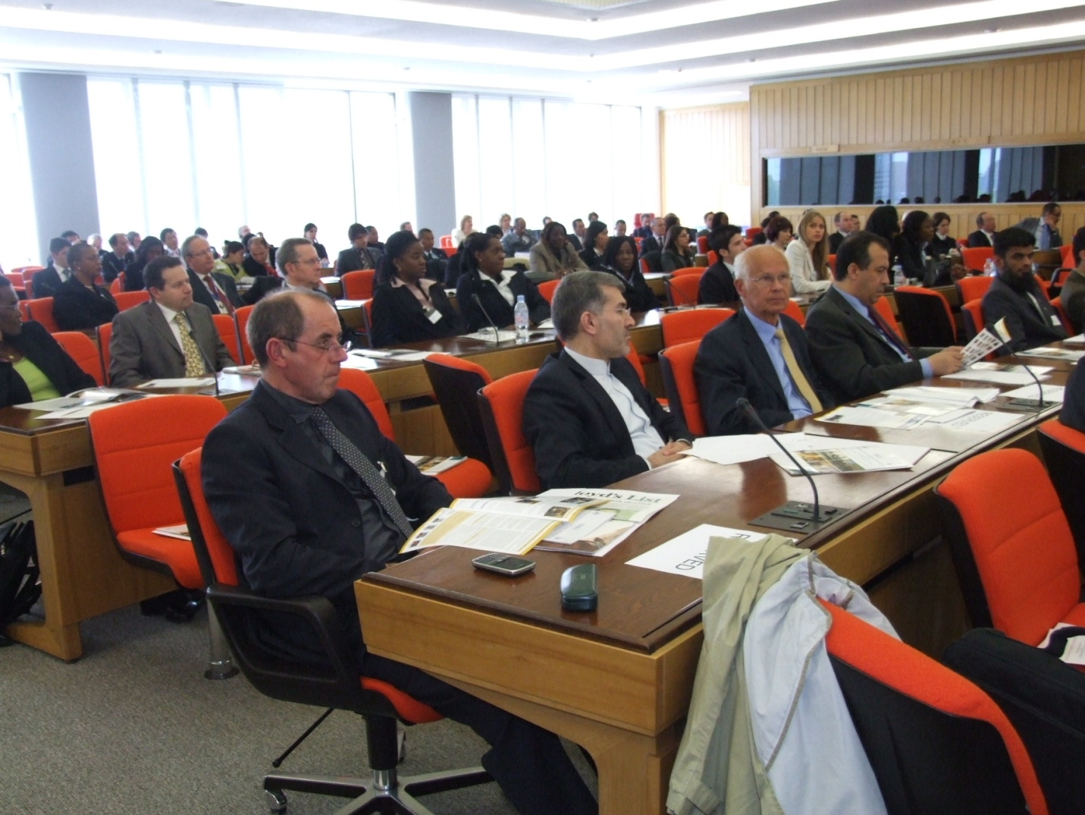

The firm belief in Malta’s vocation as an international service centre and a centre of excellence and, the commitment and dedication of the Honourable Dr Joseph Fenech Malta’s Minister responsible for maritime affairs was known to all in Malta and, also abroad to quite a number of people Dr Fenech was dealing with in his relentless pursuit of this goal. Malta’s success as an international maritime and service centre, particularly the establishment of the Maltese shipping register as one of the largest in the world but, more important still, as a most reputable flag, is in great part due to his vision and sheer determination.

The firm belief in the wide dimension that is international law to serve a new world order distinct and above the narrow approach of unilateral, national or regional action had already been amply demonstrated by Dr David Attard a man of international standing particularly in his career (or should I call it mission) as Professor of International Law at the Universities of Oxford and Malta. This vision was also to be demonstrated once more in Professor Attard’s initiative that led to global awareness and international action on climate change, incidentally the topic of this year’s World Maritime Day.

The seed that eventually gave birth to the IMO International Maritime Law had long been there.

Some men see things as they are and say, "Why?". George Bernard Shaw continued “I dream of things that never were and say, "Why not?".

It was twenty one years ago that three men of vision together worked on each other’s ideas, strengths and initiatives and in a short time, so typical of these three wise men of action, set up IMLI.

IMLI which had existed for so many years was born.

If one takes IMLI for granted one could almost be forgiven. There is such an obvious need for this institution that one wonders why it has been with us for only twenty years. During this time IMLI, without much ado, has taken its rightful place within the global international maritime law set up becoming an integral part of the training programme that is the key to the implementation of international and regional maritime law regime.

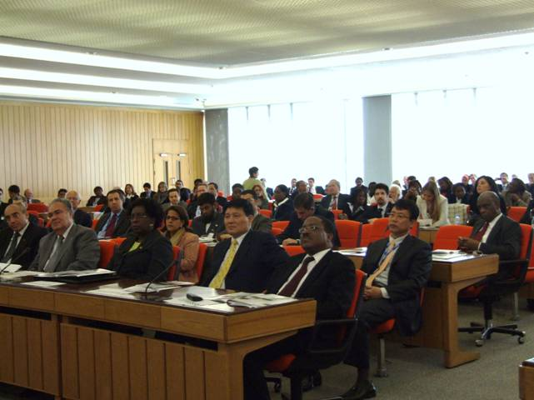

Nevertheless, the water is deeper, much deeper. During a similar celebration to that of today involving both WMU and IMLI I had said that we are celebrating the fact that the pen is mightier than the sword. I reiterate this today.

Criminalisation, unilateral action, patronization are non achievers. If, I repeat if, ever they would achieve anything it would be short term. That the quality and safety culture is becoming so universally ingrained as to guarantee a continuous process of improvement, in itself leading to implementation as a natural way forward, could only be achieved through the substantial training programme of which IMLI is one important component.

IMO has been successful, very successful. Only those with a very narrow vision, who have no idea what are the real achievements of this Organisation, who have no idea what shipping is all about, what is the maritime industry, say differently. IMO does not govern by dictat but by belief and universal application. This is the real success of IMO.

Malta is proud to be a contributor to this process particularly through IMLI which Malta proudly hosts and supports.

IMLI like WMU is motivated by the old saying usually attributed to Confucius: *Give a man a fish, and you’ll feed him for a day. Teach a man to fish, and you have fed him for a lifetime*. Translated conceptually this means: education is the most important thing you can give someone to better his circumstances. IMLI really and truly serves the rule of international maritime law.

The success and achievements of these last twenty years are a tribute to these founding fathers represented here today by none other than Professor Attard himself. The maritime industry pays tribute to three of you. Gratitude and tribute goes to you Mr O’Neil, Secretary-General Emeritus and to you Mr Secretary-General Mr Mitropoulos for your continuous support and who over the years led successive Board of Governors that included stalwarts like the late Professor Muller of Switzerland. Our grateful thanks also goes to the first IMLI Director, Professor P. Bernie, to a long list of sponsors and donors, represented here by none other than Dr Sasakawa of the Nippon Foundation who support IMLI through a belief in its need, to the resident and visiting professors and, to the IMLI staff.

Alas, each for his own reason, Dr Srivastava and Dr Fenech cannot be with us. While they would have been proud of what has been achieved, nonetheless they would have spurred us on for more. Already IMLI, emulating the oceans it serves, has spread to all four corners of the world without any political, economic or racial barriers. Considering the sceptical acceptance of the Institute in the early days this is indeed a great achievement.

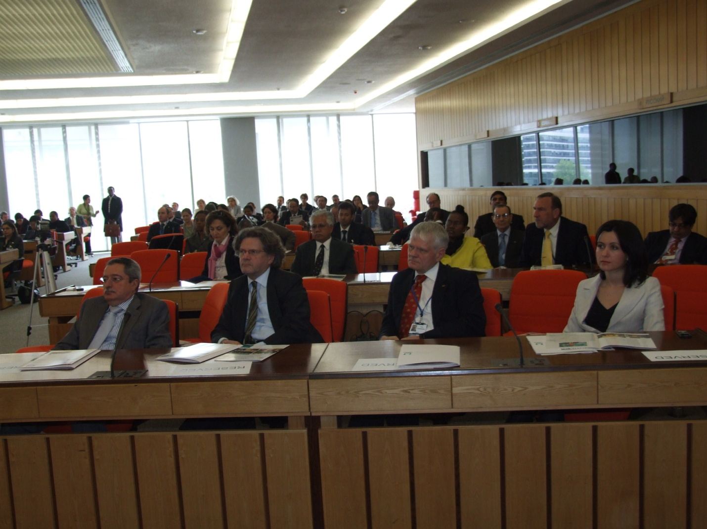

Perhaps now is the time for WMU and IMLI, while maintaining their separate identities, to collaborate to fill the gaps in the training programme, especially institutionalised short term professional training. Building on what already exists particularly the strengths of the two institutions and the diversities of their two localities but both enjoying freedom of movement between their host countries, WMU and IMLI together can ensure the wholeness of the training programme.

To the founding fathers of IMLI and to you Mr Secretary-General Malta reiterates its support not only for IMLI which we shall continue to host, but for the whole training programme. The education and training programme makes possible the realisation of the work of this Organisation in a solid and universal manner.

Dear IMLI graduates do not be disenheartened by what you have experienced here today. Life at IMO is not only listening to the podium. We await your participation. Your education and training will enrich the debate and will strengthen the universality of this organisation.

Happy birthday IMLI. Never rest on your laurels but harness the wind of your success to sail ahead.

Yet, never must we forget that the pen is mightier than the sword.

Thank you.

Ambassador Lino Vassallo has been involved in the maritime industry on the official side since 1973. He is the Executive Director Merchant Shipping within the Malta Maritime Authority and therefore ex officio the Registrar-General of Shipping and Seamen. He is also Malta’s Permanent Representative to the International Maritime Organization and the Chairman of the Mediterranean Memorandum of Understanding on Port State Control. Ambassador Vassallo regularly delivers lecturers at IMLI on the practical aspects of flag State Administration and member State participation at IMO.

1. _________________________________
2. * *If you do not want to receive IMLI e-News in future, please return this message to the above address with request to DELETE in the subject field.*
3. *\*\* For further information please contact Ms. Elda Belja (Editor, IMLI e-News) at* [publications@imli.org](mailto:publications@imli.org)