Circulated in more than 100 States to personalities in the legal and maritime professions

IMLI e-News

The IMO International Maritime Law Institute Official Electronic Newsletter       (Vol.  6 , Issue No. 56)   5 June 2009

* 1. **CHAIRMAN OF THE NIPPON FOUNDATION RECEIVES IMLI’S AWARD**



In recognition of the contribution made by The Nippon Foundation, during the Commemorative Seminar to celebrate IMLI’s 20th Anniversary held at the IMO Headquarters in London on 5 May 2009, the IMLI “Award for Meritorious Contribution towards the Dissemination, Harmonization and Implementation of International Maritime Law” was conferred upon Mr. Yohei Sasakawa, Chairman of The Nippon Foundation.

1. 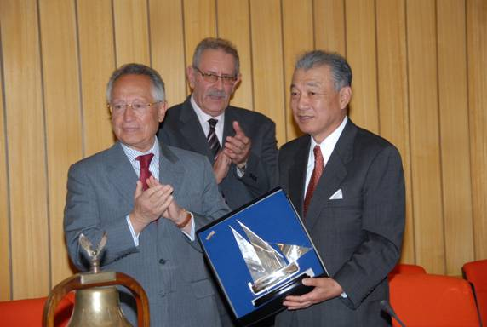

*Conferment of the IMLI “Award for Meritorious Contribution towards the Dissemination, Harmonization and Implementation of International Maritime Law” to Mr. Yohei Sasakawa (Chairman of The Nippon Foundation)*

As a result of his unwavering efforts a joint project between the two institutions entitled “Human Resources Development Project for the Advancement of a more effective Legal Order for the Oceans” was launched in 2003 demonstrating the full support of The Nippon Foundation to the Institute’s objectives.

The aim of this common undertaking is to contribute to the promotion, adoption, effective implementation and enforcement of international maritime conventions adopted under the aegis of the United Nations and the International Maritime Organization, and to encourage greater participation by developing States, particularly Asian, in the major international maritime law conventions and legal instruments.

The Project has been successful due to the fruitful collaboration between the two organizations. To date, the Project continues to offer post-graduate study and research opportunities in international maritime law for deserving candidates. For this purpose the Institute provides its academic and technical expertise and The Nippon Foundation is generously providing scholarships which enable deserving candidates to pursue their studies in international maritime law at the Institute.

In total, so far, fifty-six lawyers from thirty-two States have benefited from the scholarships awarded under the Project.

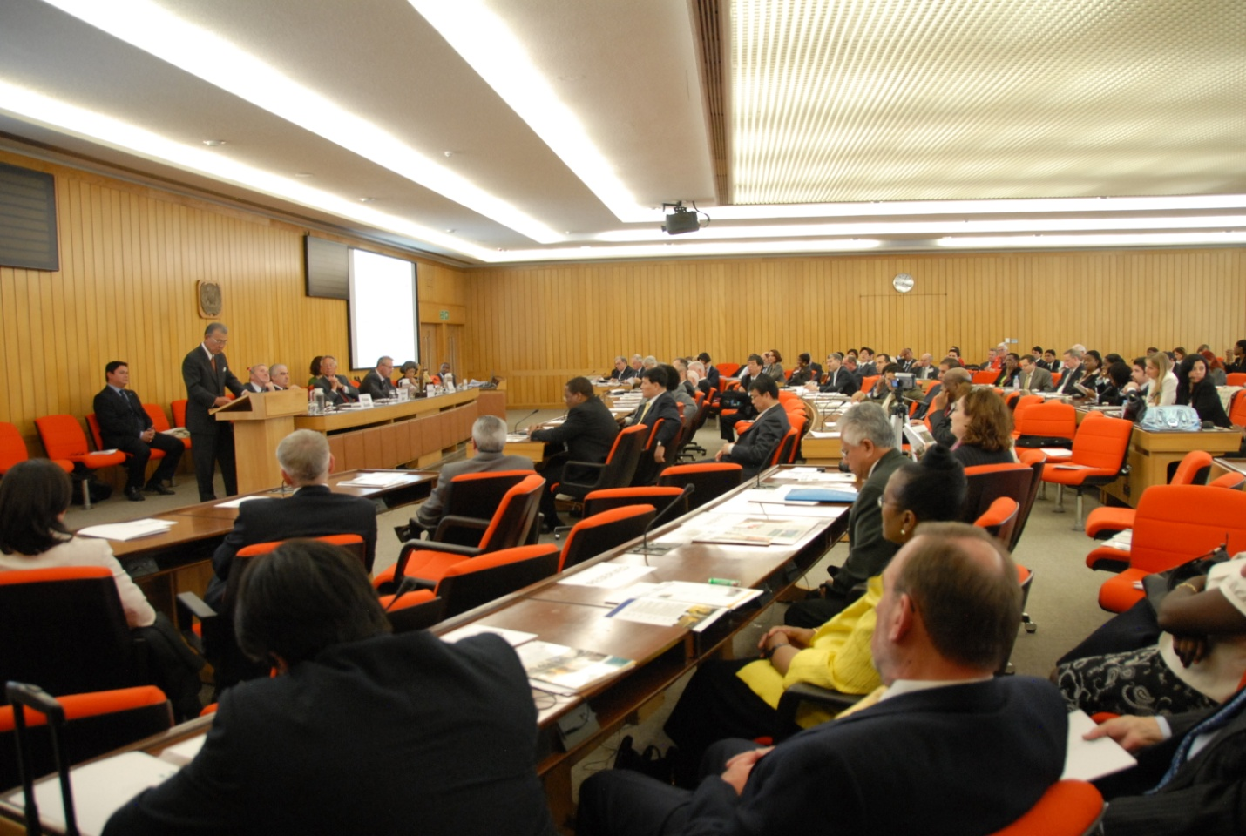

*Mr Yohei Sasakaw delivering his address on “IMLI’s Role in Capacity Building”*

In his address on “IMLI’s Role in Capacity Building” Mr. Sasakawa noted that “Six years ago, The Nippon Foundation launched a scholarship program to develop the human resources needed to promote a maritime legal order around the world. In these six years, we have provided scholarships to 56 recipients in 32 countries. I am very proud that our program has contributed, even in a modest way, to the development of IMLI and the international maritime community. I am equally proud that our efforts in support of IMO and the Institute’s development are being recognized in this way. I am well aware, however, that in receiving this award, we are also being encouraged to make even greater contributions to the Institute’s development in the years ahead. I am very pleased, naturally, to accept this award along with the commitment that it implies.”

_________________________________

1. * *If you do not want to receive IMLI e-News in future, please return this message to the above address with request to DELETE in the subject field.*
2. *\*\* For further information please contact Ms. Elda Belja (Editor, IMLI e-News) at* [publications@imli.org](mailto:publications@imli.org)