Circulated in more than 100 States to personalities in the legal and maritime professions

IMLIe-News

The IMO International Maritime Law Institute Official Electronic Newsletter       (Vol.  6 , Issue No. 6)    6 October 2008

**VICE-PRESIDENT HONORIS CAUSA OF THE COMITÉ MARITIME INTERNATIONAL**

**LECTURES AT IMLI**

Professor Frank L. Wiswall, Jr., Vice-President honoris causa of the Comité Maritime International (CMI) has begun delivering his lectures for IMLI’s 20th annual LL.M. programme. The first set of lectures is dedicated to the study of “Maritime Legal History”, whereas the second part of his lectures will focus on “Maritime Legislation Drafting”.

Professor Wiswall has been a visiting fellow at IMLI’s LL.M. programme for almost 20 years. As Professor Attard recalled in his welcoming address, Professor Wiswall was one of the first eminent maritime academics that realized the important role that IMLI would have in the maritime field and has unrelentingly supported its activities.

Indeed, Professor Wiswall’s contribution to the work of the Institute dates back to the time when the L.L.M programme’s syllabus was being prepared. He has been for a number of years a Member of the IMLI Governing Board and was also appointed this year a member of the IMLI Academic Committee.

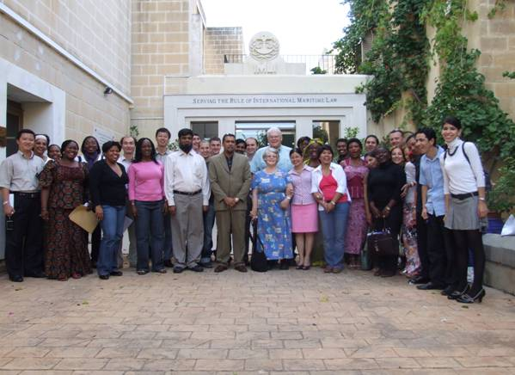

*Professor and Mrs. Frank L. Wiswall Jr. with the*

*IMLI Class 2008-2009*

________________________________________________________________________

 * If you do not want to receive IMLI e-News in future, please return this message to the above address with request to DELETE in the subject field.

** For further information please contact Ms. Elda Belja (Editor, IMLI e-News) at [publications@imli.org](mailto:publications@imli.org)