Circulated in more than 100 States to personalities in the legal and maritime professions

IMLIe-News

The IMO International Maritime Law Institute Official Electronic Newsletter       (Vol. 6, Issue No. 7) 10 October 2008

**PRESIDENT EMERITUS OF MALTA DELIVERS A COURSE OF COMPARATIVE LAW AT IMLI**

H.E. Dr. Ugo Mifsud Bonnici, President Emeritus of Malta, is currently delivering a course on comparative law to the 20th generation of IMLI lawyers. His lectures focus on a wide range of topics including, *inter alia*, *“*The Mainstream of Law in the West”,*“*The Specific Nature of the Anglo –Saxon Common Law System”, *“*Law in Islamic Countries”, and “Laws and Change: The Drafting of new Laws”.

The aim of the lectures is to compare the different legal systems and legal traditions, such as the Civil Law, Common Law and Shari’ah, as well as other systems that have derived from the above mentioned. The study of comparative law is given much importance at IMLI, as it is an important key to understanding the present-day legal systems of the world, and it is of paramount importance in the study of maritime law from an international perspective.

When previously asked about the relevance of the study of comparative law, Dr. Bonnici pointed out that: *“Maritime law is international. It does not rely on just one system of law; it must deal with several jurisdictions and several systems of law. To maritime lawyers knowledge of comparative law is fundamental. In the years that I have taught at IMLI, I have learned that students are interested in the diversity of law. My contact with IMLI students has also enriched my own knowledge of comparative law because of the exchange I have had with the students themselves.”*

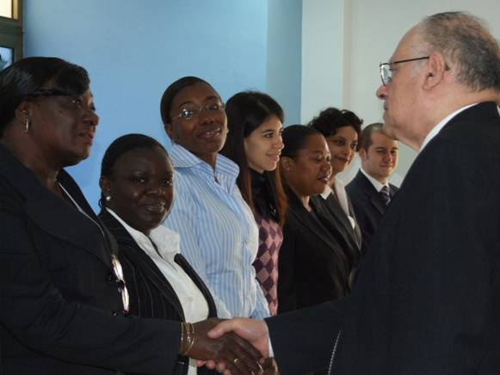

H.E. Dr. Ugo Mifsud Bonnici, President Emeritus of Malta,

meeting the students of the IMLI Class of 2008-2009

H.E. Dr. Ugo Mifsud Bonnici was President of Malta between 1994 and 1999. Prior to that (in 1987) he was appointed to the Cabinet as Minister of Education. His portfolio included Education, Environment, Broadcasting, Culture, Youth, Museums and Sport.

As a Member of Parliament, he took an active interest in the updating of Malta's legislation and he was a member of numerous selected Committees including the Committee set up to draft the Constitutional changes that declared Malta a Republic.

__________________________________

 * If you do not want to receive IMLI e-News in future, please return this message to the above address with request to DELETE in the subject field.

** For further information please contact Ms. Elda Belja (Editor, IMLI e-News) at [publications@imli.org](mailto:publications@imli.org)