Circulated in more than 100 States to personalities in the legal and maritime professions

IMLIe-News

The IMO International Maritime Law Institute Official Electronic Newsletter       (Vol.  6 , Issue No. 9)   24 October  2008

**ROBERT LLOYD’S PAINTING OF IMLI UNVEILED AT LONDON IMO HEADQUARTERS**

IMLI’s contribution to the international maritime community was recognized by the IMO with the unveiling of a painting of the Institute during the official opening of the refurbished IMO building in London by H.R.H. The Duke of Gloucester. The IMLI painting, work of Robert Lloyd, was unveiled by Mr. Lino Vassallo (Malta’s Permanent Representative to IMO) and Professor David Attard (IMLI Director) and now hangs proudly at the entrance of IMO’s Main Hall.

H.E. Efthimios Mitropoulos (IMO Secretary-General) stated that the IMLI’s painting, together with a painting dedicated to the WMU, had been commissioned “as an expression of our strong wish that, through this opportunity, we celebrate, among the many other achievements of IMO, two institutes of excellence in their respective academic fields”. The unveiling of the painting, which coincided with the commencement of IMLI’s 20th academic year, purports to recognize IMLI’s role in the service of the rule of international maritime law.

The Secretary-General took the opportunity to thank the host countries of the institutes, Malta and Sweden, as well as to express his gratitude for the support received over many years from a number of other sponsors and donors.  He went on to acknowledge the central role of the past and current Directors of IMLI, and of the past Rectors and current President of WMU, whose responsibility it has been to oversee the successful operation and continuing development of both centres.

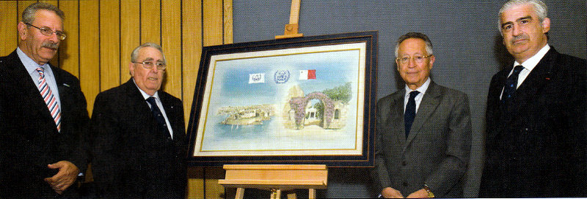

*Mr. Lino Vassallo(Malta’s Permanent Representative to IMO), H.E. Dr. Michael Refalo (High Commissioner of Malta), H.E. Efthimios Mitropoulos(IMO Secretary-General)  and Professor David Attard (IMLI Director)*

________________________________

* *If you do not want to receive IMLI e-News in future, please return this message to the above address with request to DELETE in the subject field.*

*\*\* For further information please contact Ms. Elda Belja (Editor, IMLI e-News) at* [publications@imli.org](mailto:publications@imli.org)